**INTERNATIONAL HYDROGRAPHIC ORGANIZATION**



**MARITIME LIMITS AND BOUNDARIES**

**PRODUCT SPECIFICATION**

**IHO Publication S-121**

**Annex F**

**Derivation of Classes**

**(Informative)**

**Version 1.0.0 – February 2019**

Published by the

International Hydrographic Organization

4b quai Antoine 1er

Principauté de Monaco

Tel: (377) 93.10.81.00

Fax: (377) 93.10.81.40

E-mail: [info@iho.int](mailto:info@iho.int)

Web: [www.iho.int](http://www.iho.int)

|  |
| --- |
| © Copyright International Hydrographic Organization 2019 |
| This work is copyright. Apart from any use permitted in accordance with the [Berne Convention for the Protection of Literary and Artistic Works](http://www.wipo.int/treaties/en/ip/berne/trtdocs_wo001.html) (1886), and except in the circumstances described below, no part may be translated, reproduced by any process, adapted, communicated or commercially exploited without prior written permission from the International Hydrographic Organization (IHO). Copyright in some of the material in this publication may be owned by another party and permission for the translation and/or reproduction of that material must be obtained from the owner. |
| This document or partial material from this document may be translated, reproduced or distributed for general information, on no more than a cost recovery basis. Copies may not be sold or distributed for profit or gain without prior written agreement of the IHO Secretariat and any other copyright holders. |
| In the event that this document or partial material from this document is reproduced, translated or distributed under the terms described above, the following statements are to be included: |
| *“Material from IHO publication [reference to extract: Title, Edition] is reproduced with the permission of the IHO Secretariat (Permission No ……./…) acting for the International Hydrographic Organization (IHO), which does not accept responsibility for the correctness of the material as reproduced: in case of doubt, the IHO’s authentic text shall prevail. The incorporation of material sourced from IHO shall not be construed as constituting an endorsement by IHO of this product.”* |
| *“This [document/publication] is a translation of IHO [document/publication] [name]. The IHO has not checked this translation and therefore takes no responsibility for its accuracy. In case of doubt the source version of [name] in [language] should be consulted.”*  The IHO Logo or other identifiers shall not be used in any derived product without prior written permission from the IHO Secretariat. |

Document Control

Changes to this document are coordinated by the IHO S-121 Project Team (S-121PT) which is a subsidiary group of the S-100 Working Group (S-100WG). New editions of this document will produced in coordination with the S-121 Product Specification, and will be made available on the IHO web site.

|  |  |  |  |
| --- | --- | --- | --- |
| Edition Number | Date | Author | Purpose |
| Draft Edition 1.0.0 | April 2018 | S-121PT | Approved by HSSC 10 under the new review cycle for testing. (Reference; HSSC10/16) |
| Draft Edition 1.0.1 | January 2019 | S-121PT | Minor revision after S-121 Project Team meeting December 2017 reflecting the inheritance of classes to support the minor revisions to the Product Specification document. |
| Edition 1.0.0 | February 2019 | IHO Sec | Revised format and structure. |

Overview

S-121 is a Product Specification for Marine Limits and Boundaries which is built upon both the IHO S-100 Universal Hydrographic Model standard and the ISO TC211 Geographic Information suite of standards, including the ISO 19152 Land Administrative Domain Model. S-121 inherits the capability to describe the legal rights, restrictions and responsibilities and associated parties from the ISO standards. This permits support for a full description of the information needed for submission to the UN under the Convention of the Law of the Sea (UNCLOS). This document shows how each class in the S-121 Application Schema and Feature Catalogue inherit from the base S-100 and ISO classes.

**This Annex is for informational purposes only in support of the S-121 Product Specification.** The S-121 Product Specification is a complete stand-alone document that is sufficient to understand and implement the S-121 product.

The description of the derivation of classes in a separate Annex makes the S-121 Product Specification much simpler. The Product Specification document will be used by states or agencies producing or interpreting data. This Annex on the derivation of classes is a support document intended primarily for the developers of software who wish to know the detailed relationship between the S-121 structures and other S-100 based Product Specifications; and for the members of the S-121 Project Team to discuss the structure of the Product Specification.

Table of Contents

Overview iv

1 Introduction 1

2 Managing Legal Rights 1

3 Features and Attributes in S-121 2

3.1 Feature Catalogue Structure 5

3.2 Feature and Attribute Structure 6

3.2.1 Basic Administrative Unit Package 9

3.2.2 Feature Unit 10

3.2.3 Spatial Attribute 12

3.2.4 Party Unit Package 23

3.2.5 RRR Administrative Package 24

3.2.6 RRR Structure 25

3.2.7 Governance Object 26

3.2.8 Versioned Object 28

4 Using the S121 RRR Structure 30

# Introduction

This document describes the derivation of classes used in the S-121 Marine Limits and Boundaries Product Specification. S-121 is based on the IHO S-100 Universal Hydrographic Data Model and the ISO TC211 suite of Geographic Information Standards. In order to support the legal attributes source referencing and versioning, S-121 also inherits objects used to define Rights, Responsibilities and Restrictions, Parties and Source structures from the ISO 19152 standard Land Administrative Domain Model. This document illustrates how each of the classes defined in the S-121 Product Specification are inherited or realized from these base standards.

# Managing Legal Rights

The Land Administrative Domain Model (LADM) standardized in ISO standard 19152 establishes a rigorous mechanism for handling legal Rights, Responsibilities and Restrictions (RRR) for individuals, groups or other parties. This mechanism can be used in the IHO standard S-121 Marine Limits and Boundaries and in other marine application areas such as a Marine Cadaster. The title of the ISO standard says “Land Administrative Domain Model” however the scope of the ISO standard says “including those over water and land, and elements above and below the surface of the earth”[1].

This document outlines how Maritime Limits and Boundaries and other marine application areas can be handled in alignment with the RRR and Party structures inherited from ISO 19152. The goal of the Universal Hydrographic Data Model defined in S-100 is to cover all aspects of hydrographic and marine information. In the land domain there are also new structures being standardized in ISO and other forums, to address areas such as land cadaster, land cover, etc. Integrating other information domains for the marine environment that include legal, economic and management aspects related to the ocean can build upon this work in ISO.

It is very important for associated legal attributes to be used together with Maritime Limit and Boundary (MLB) information so that one can determine under whose authority, or international treaty a particular limit or boundary is defined. Similar processes of defining MLBs exist in many countries; however, they are not exactly the same so that there may be differences in how information is defined in various jurisdictions. The IHO standard S-121 on Maritime Limits and Boundaries must be general enough to satisfy the requirements of all nations since boundary information involves more than one state actor. Accurate calculation and representation of the resultant boundaries and documentation of the original legal sources are of great importance. There can be significant legal and political implications resulting from errors.

Maritime Limits and Boundaries information may be used in many different ways. Because there may be several different state actors involved with different technological approaches and levels of sophistication in their system implementations, the management of legal rights needs to be very flexible. This document describes the structure upon which a Product Specifications such as Marine Limits and Boundaries will be based, since all information found within the extensions depends upon the legal and administrative entities described here.

# Features and Attributes in S-121

The ISO suite of geographic information standards and the IHO S-100 Universal Hydrographic Data Model are built upon an object structure. In the object structure a real world feature is an object that has properties. These properties are represented as attributes and associations. The attributes are of two types, Spatial Attributes describing its geometric representation, and Thematic Attributes describing the nature of the object. There may also be constraints placed upon an attribute or association. The IHO S-100 has added to the ISO General Feature Model the concept of Named Types, to allow for the definition of Feature Types and Information Types.

A feature has existence in the real world. A particular feature instance could be a rock or a segment of coast line. Limits and Boundaries are also features with existence in the real world.

An information object is an object with no real geographic spatial position. In a navigational chart it may be something like a note that can appear on a chart. Information objects can have thematic attributes and so they can be used to implement the Administrative Objects that describe Rights, Restrictions and Responsibilities and Parties derived from the ISO 19152. Administrative Objects are real objects but they have no geographic spatial position.

The S-100 standard allows for the specialization of features and information objects by the addition of attributes and the definition of any number of thematic attributes; however, it does not allow for the specialization of spatial attributes. There is a practical reason for this. Restricting the extension of the S100_GF_SpatialAttributeType makes the implementation of systems based on S-100 simpler because there is only one spatial attribute type that need to be implemented.

S-121 includes additional ways of describing position inherited from the ISO standard 19152. These are the description of a spatial attribute textually called “location by text” and the description of a position in a coordinate reference system different that that used to describe other positions. Both cases occur in real legal data. A treaty or law may describe a position as “an extension of a line from …” or by some other descriptive means. Also the reference system used in a treaty or law may be in a coordinate reference system that was used at the time the treaty or law was written. Since this textual description or position in a unique coordinate reference system are what is described in the treaty or law they are the correct legal position and must be included as is in the S-121 data. However, for a Geographic Information System to work, and for it to be possible to calculate geometries it is necessary for all the spatial attributes to be in the same coordinate reference system. This means that either the S-100 spatial attribute needs to be extended or a new information object carrying this additional legal information as attributes needs to be defined. In order to maintain compatibility with the other S-100 Data Products an additional spatial information object with attributes is defined called   
“S-121_additionalSpationalInformationType”.

The ISO standard 19152 also allows for per object versioning. All of the feature and thematic attributes in S-121 may optionally be versioned. Versioning in the other S-100 based Data Products is done at the dataset level. Because the S-121 Spatial Attribute must match the S-100 Spatial Attribute exactly per object versioning is not directly available.

In S-100 spatial attribute objects may be shared. There may be several Feature objects that share the same spatial attribute by reference. For example a curve may be the spatial attribute object referenced by a limit and also be the boundary or an adjacent zone. Similarly in S-121 the additional spatial information object with its attributes may be shared. A constraint is defined that locks the additional spatial information object to the corresponding S-121 Spatial Attribute object. Since the additional spatial information object and the S-121 Spatial Attribute object are locked together they must handle versioning in the same manner. Versioning of the S-121_ S121_AdditionalSpatialInformation object also applies to the corresponding S121_SpatialAttribute object. Bothe objects need to be maintained together.

Figure 1 Shows a Feature Object and its Associated Attributes taken from the IHO S-100 standard. This figure shows the S121_GF_FeatureType, S121_GF_InformationType, S121_GF_ThematicAttributeType and the S121_GF_SpatialAttributeType as specializations of the corresponding S-100 classes. The S121_GF_SpatialAttributeType corresponds directly with the S100_GF_SpatialAttributeType.

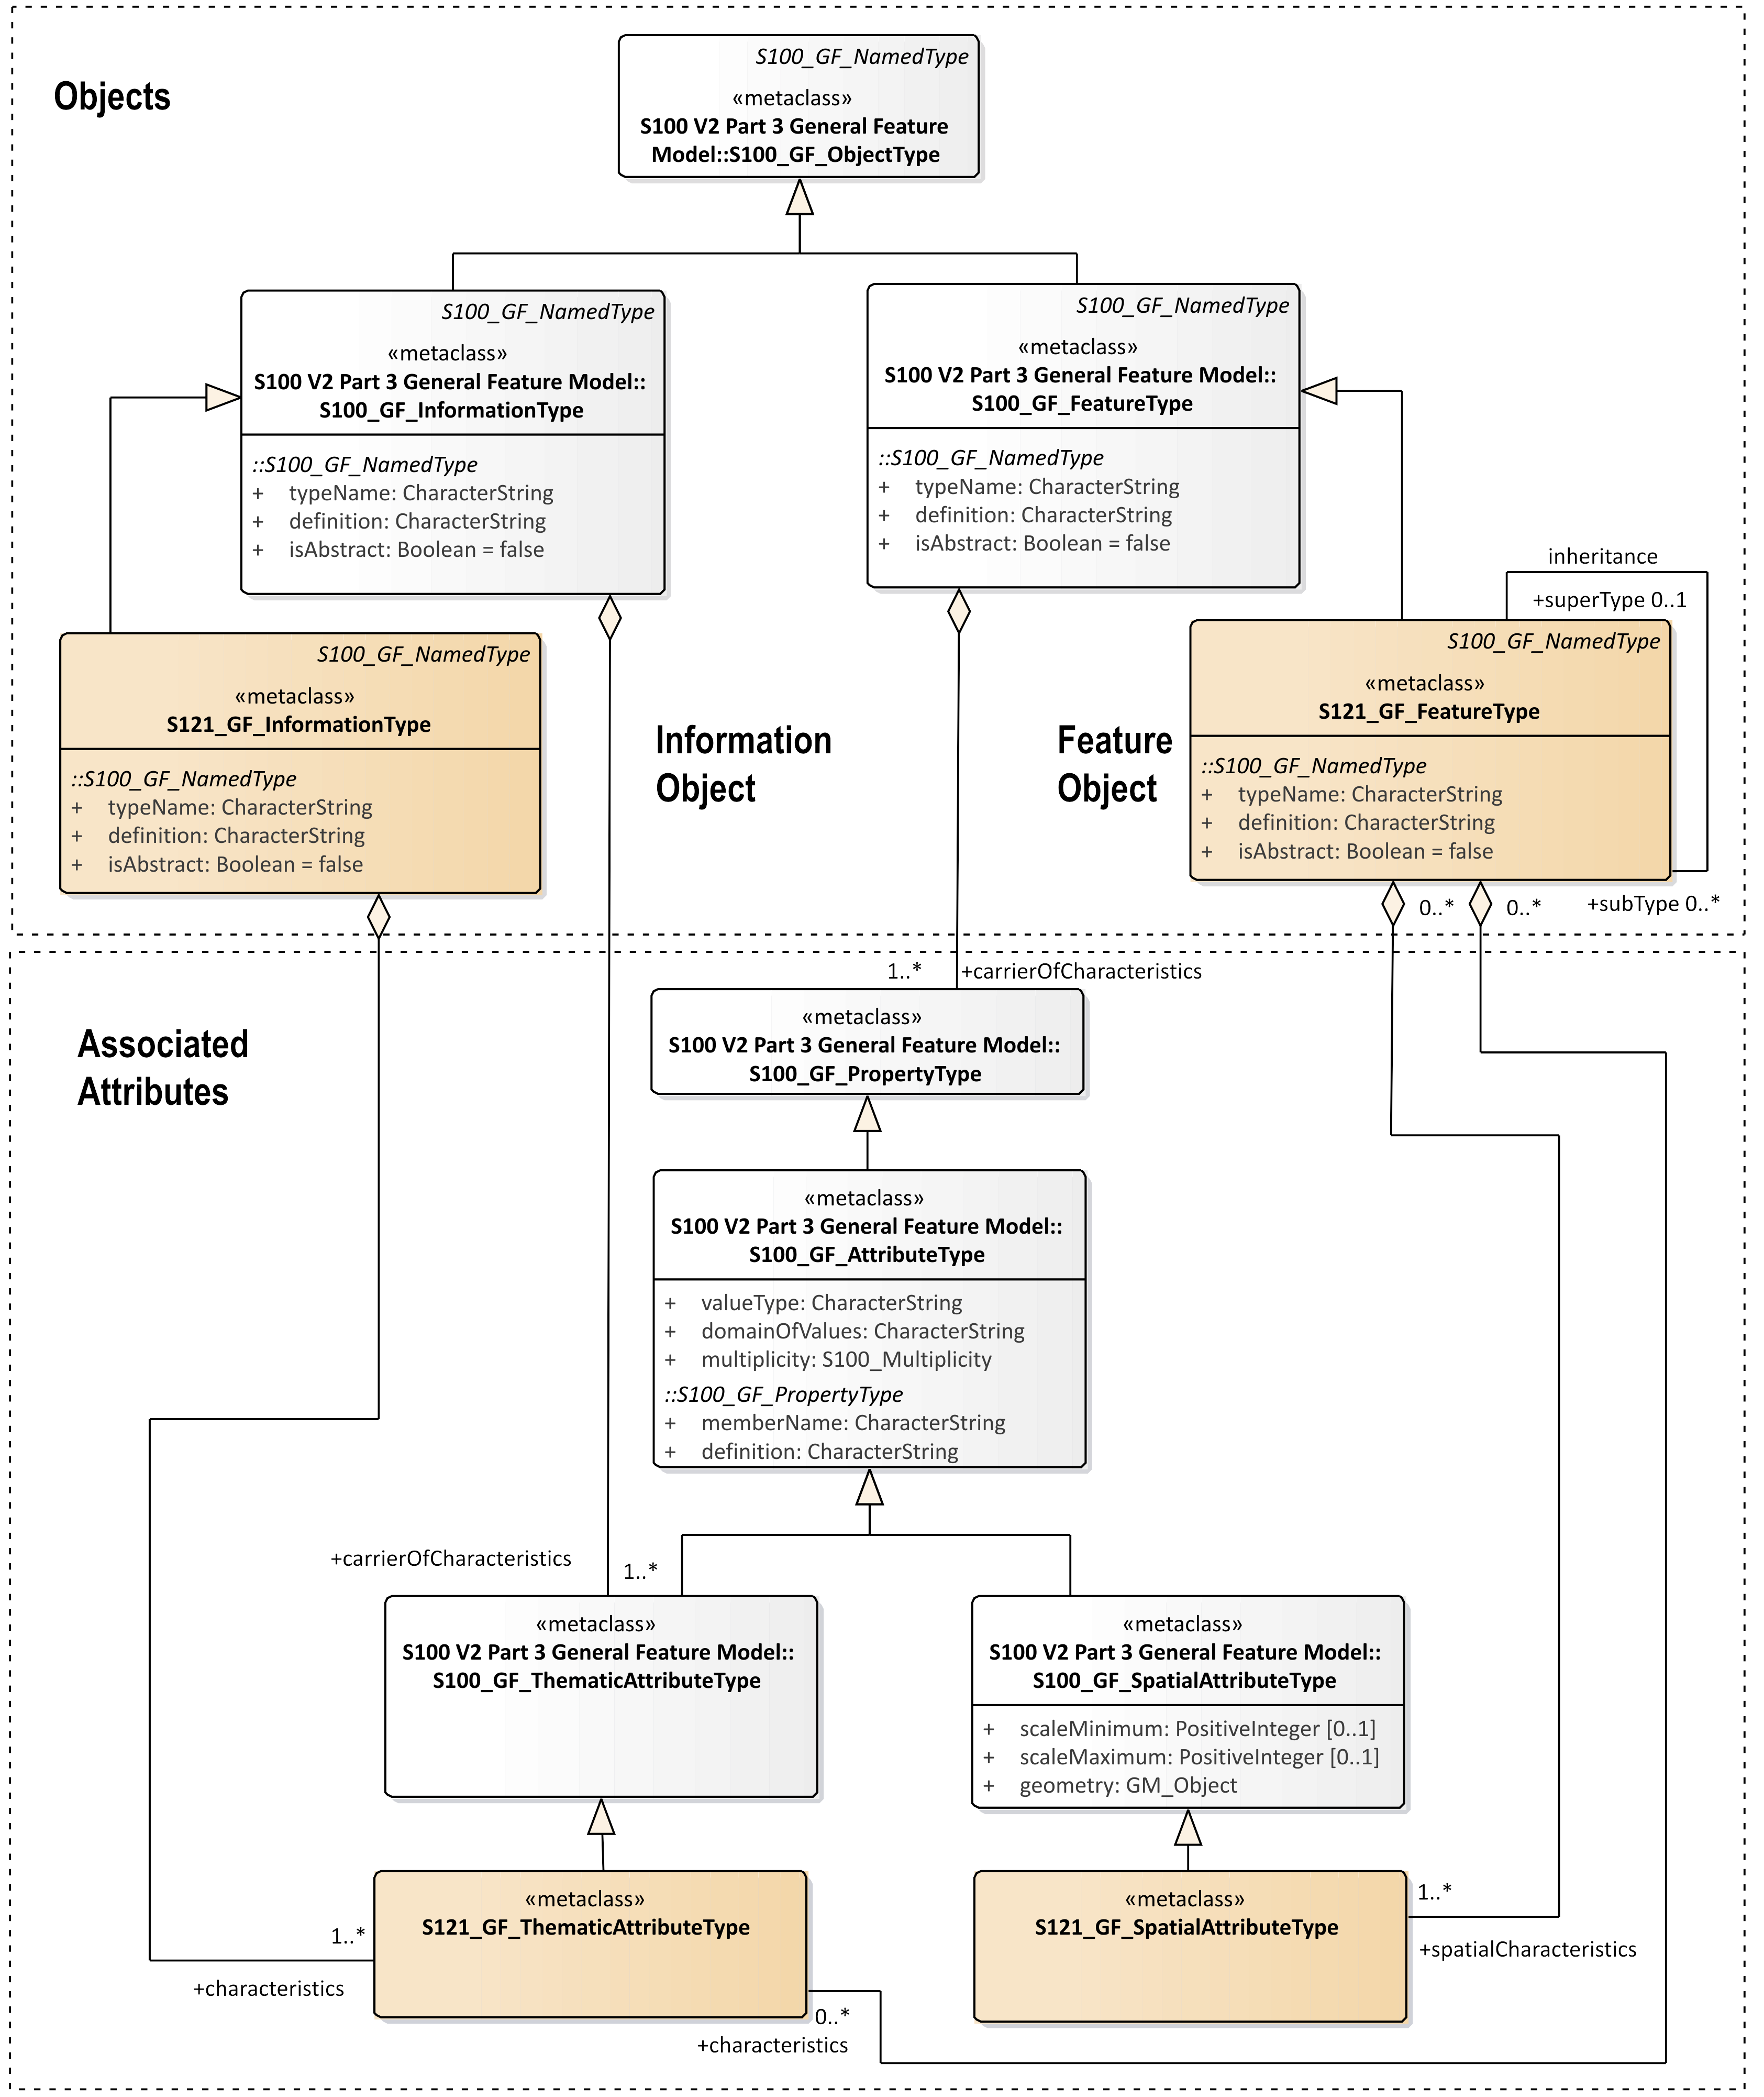

Figure 1 – General Feature Model with S-121 Specialized Feature and Attribute Classes

The General Feature Model is a metamodel; that is, it is a template upon which actual Application Schema are defined. Every data set has an Application Schema that defines the allowable objects and attributes and the allowed relationships for that particular type of data set. There is a hierarchy of models ranging from the abstract metamodel template to the specific application schema and to the specific set of instance data corresponding to a particular instance of a data set. S-121 defines four new classes at the General Feature Model (template metamodel) level. It specializes S100_GF_FeatureType, S100_GF_InformationType, S100_GF_SpatialAttributeType and S100_GF_ThematicAttributeType. The new metaclass S121_GF_ThematicAttributeType supports relationships to the Administrative Structure (Rights, Restrictions and Responsibilities, and Basic Administrative Unit), which is inherited from the ISO 19152 standard.

The feature type object takes its definition from the S-100 object S100_GF_FeatureType and the information type object takes its definition from the S-100 object S100_GF_InformationType. All of the inherited attributes are shown in the S121_GF_FeatureType object and in the S121_GF_InformationType object. These inherited attributes are:

*typeName* = Name of the named type. The name shall be unique within a namespace.

*definition* = Definition that describes the named type.

*isAbstract* = Boolean attribute. If true, the named type acts as an abstract supertype. It is not possible to create an instance of an abstract type.

Attributes provide detail that establish context for a feature. S-100 defines two types of attributes that may be associated with a feature. These are spatial attributes and thematic attributes. The spatial attribute references GM_Object from ISO 19107 for the geometry.

An important restriction is that S-100 limits the types of spatial primitives that may be used to represent the object to GM_Point, GM_MultiPoint, GM_Curve, GM_Surface, CV_Coverage, GM_Curve (arcByCentrePoint and circleByCentrePoint). This is a simplification from the more extensive set of primitives available in ISO 19107 Spatial Schema upon which both the ISO 19152 LADM and the IHO S-100 are based. This subset makes the implementation of systems such as an ECDIS[2] system easier by limiting the types that need to be implemented. This restriction is important in S-100 because navigations systems must be testable to ensure safety. For compatibility this same restriction carries through to other marine application areas such as a Maritime Limits and Boundaries and a Marine Cadaster. Therefore the S121_GF_SpatialAttributeType remains equivalent to the S100_GF_SpatialAttributeType.

## Feature Catalogue Structure

All named types, features, information objects and attributes have their definitions recorded in a feature concept dictionary. For a particular product specification such as S-121 Maritime Limits and Boundaries, or S-101 Electronic Nautical Chart a set of allowable features and attributes are selected from the Feature Concept Dictionary. The attributes that may be used with the features in the context described in the product specification are then bound to the feature. Navigation and legal descriptions are very different contexts so it is natural that different attributes are bound to the features in these different contexts.

**The S-121 Product Specification is based on S-100 and uses the same general feature model, attribute structure and spatial schema as is used in S-100.** S121 defined features and their direct attributes can be used in other S-100 based products and will work directly. However, in S121 a number of information objects have been defined. These objects carry thematic attributes (as permitted in the S-100 General Feature Model). These objects act as attributes by reference to the S-121 Features; that is, they define a structure for the legal attributes and sources that is referenced by the S-121 Features. In short, the use of information objects to describe the legal attributes and sources avoids the need to define attributes on attributes.

The feature catalogue contains entries for feature types and information types as well as for attribute types (including code list attributes) and the listed values of code lists. Figure 2 illustrates the classes that are recorded in the Feature catalogue.

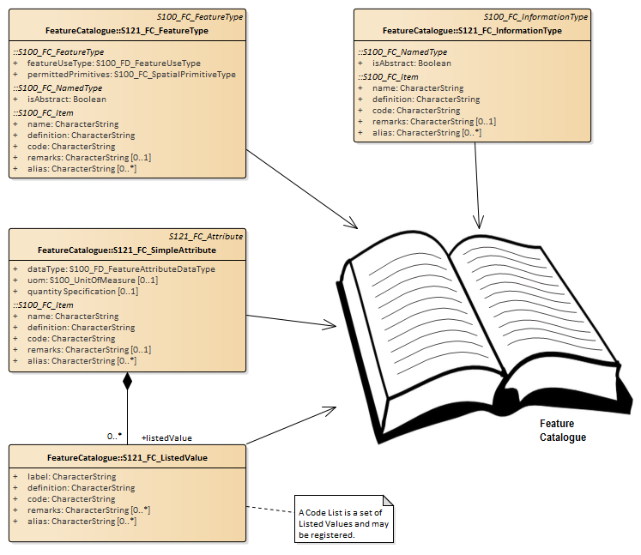

Figure 2 – Information Recorded in the Feature Catalogue

## Feature and Attribute Structure

There are two types of attributes, simple attributes and complex attributes. Both have a name, definition and code. In addition a simple attribute has a data type and optionally a unit of measure and quality. A simple attribute may have a set of listed values, which are also defined in the Feature Catalogue. A complex attribute has a set of bindings that link attributes and listed values. This structure derives directly from S-100 and is illustrated in Figure 3. This structure allows the recording of attributes and code lists / enumerations (sets of listed values) in the Feature Concept Dictionary and in the Feature Catalogue.

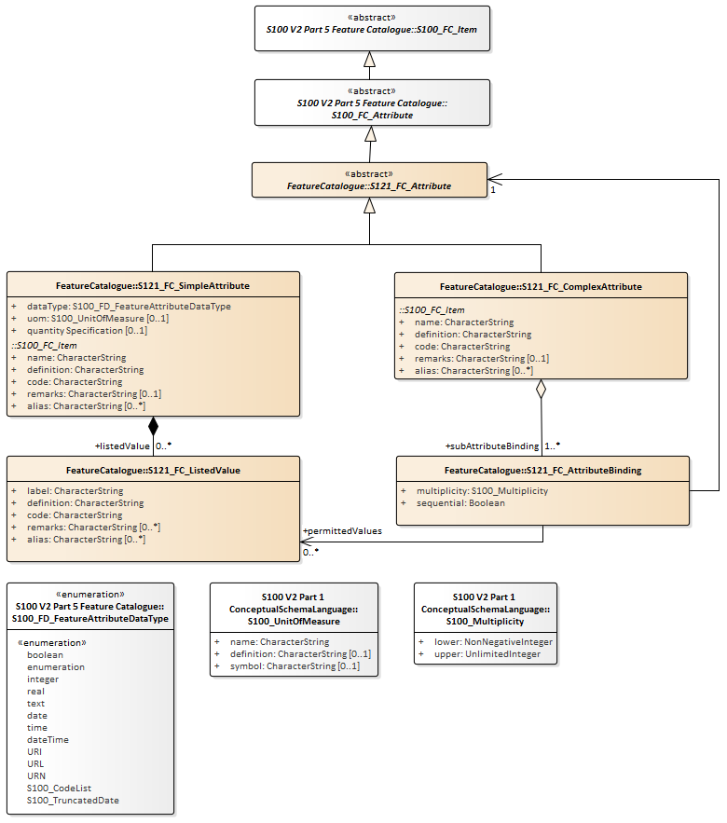

Figure 3 – Feature Catalogue Attributes

For the establishment of the Electronic Nautical Chart (ENC) data product and for specific other data products, the definition of attributes has been guided by a wealth of experience in creating paper navigational charts, and scientific experience in bathymetry, currents, tides etc. However, when one broadens the scope to more general topic areas which IHO intends to cover, such as Marine Limits and Boundaries, Cadaster, resource management and general spatial data infrastructure, the definition of attributes becomes more involved. There are many ways to describe the same conditions and some consistency is required. This is especially true of attributes that involve legal rights where consistency is very important.

Experience in this area comes from land administration, and this experience has been documented in the Land Domain Administrative Model (LADM) standardized in ISO. The standard ISO 19152:2012 Geographic information -- Land Administration Domain Model (LADM) “defines a reference Land Administration Domain Model (LADM) covering basic information-related components of land administration (including those over water and land, and elements above and below the surface of the earth)”. The LADM “provides an abstract, conceptual model with four packages related to parties (people and organizations); basic administrative units, rights, responsibilities, and restrictions (ownership rights); spatial units (parcels, and the legal space of buildings and utility networks); spatial sources (surveying), and spatial representations (geometry and topology)”.

There is a need for consistency that the LADM parties (people and organizations) and basic administrative units, rights, responsibilities, and restrictions structure provides. Since the LADM and IHO S-100 are both built on the ISO TC211 suite of Geographic Information standards, these elements are compatible and can be inherited into IHO.

Figure 4 illustrates the Domain Administrative Area Classes defined in the ISO 19152 LADM. The basic administrative units (LA_BAUnit) are the basic elements of the legal attribute structure. They relate to features and attributes (LA_SpatialUnit), which may be defined in several ways. The explicit geometry used is S-100 is compatible. Rights, restrictions and/or responsibilities (LA_RRR) relate parties (LA_Party) to the basic administrative units (LA_BAUnit). The ISO Domain Administrative Model standard uses the same types (LA_BAUnit) and spatial geometry (LA_SpatialUnit) as all of the other ISO standards, but it adds the rights, restrictions and responsibilities related to parties or groups of parties. The LA_SpatialUnit corresponds to a feature in the ISO 19109 General Feature Model and the LA_BAUnit is a collection object that allows the expression of the relationships between the Rights, Restrictions, Responsibilities and Parties to the features.

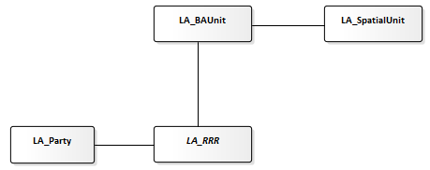

Figure 4 – Domain Administrative Classes

ISO 19152 also provides the capability to version objects. This Versioned Object structure is extremely valuable in the MLB application area (and in other application areas such as Marine Cadastre). In the area of nautical charts, for both paper charts and ENCs, the whole chart or data set is versioned. This is an appropriate approach for this type of data product; however, for Marine Limits and Boundaries and for Marine Cadastre it is necessary to be able to manage the version of features and attributes at the individual object level. For example, the rights to a fishing zone may change without altering anything else. Individual versioning of objects allows changes to be managed at a fine level. Versioning at the object level is also appropriate in a Marine Spatial Data Infrastructure (MSDI) where feature data may be available through a Web Feature Service interface[3].

### Basic Administrative Unit Package

The Basic Administrative Unit as defined for S-121 is derived from the class LA_BAUnit defined in ISO 19152 which relates rights, responsibilities or restrictions to the feature structure. This class is related to the S121_FeatureUnit. S121_BAUnit is a realization of the class S121_ThematicAttributeType. For example a collection of features represented by several S121_FeatureUnit objects may have a relationship to the same set or rights, restrictions and/or responsibilities and parties. It “carries the characteristics” expressed by the administrative structure and relates it to the feature. The S121_BAUnit object also inherits from ISO 19152 VersionedObject. This allows the definition begin and end lifespans for an object and also provides optional quality and source references. This is illustrated in Figure 5.

Realization relationships are used to prevent double inheritance. The relationship between LA_BAUnit and S121_BAUnit is a “realize” relationship because only some of the attributes are inherited. One attribute *type* is overwritten with a different code list that is appropriate for a marine environment since the list from ISO 19152 is land oriented. Attribute values such as basicPropertyUnit and leasedUnit are only needed in a land cadaster.

The relationship between S121_GF_ThematicAttributeType and S121_BAUnit is also a “realize” relationship. Since S121_GF_ThematicAttributeType is a metaclass only some of the attributes are required. The *definition*, *valueType, domainOfValues* and *multiplicity* attributes are recorded in the Feature Concept Dictionary and are not required as part of S121_BAUnit. The *memberName* attribute from S-100 is inherited and is renamed as *basicAdministrativeUnitName*. The attribute name is in "CamelCase" in line with the naming rules for the S-100 Feature Concept Dictionary. Long descriptive names are used that do not include acronyms.

The primary source for the model is IHO S-100. This provides direct compatibility with other IHO product specifications. The inheritance from ISO 19152 allows for compatibility with Land Cadastre and land based limits and boundaries. Those structures and attributes from the Land Administrative Domain Model that do not apply to a marine environment are not inherited.

The attribute uID is used in relationships between instances of the S121_BasicAdministrativeUnit and Rights, Restrictions and/or Responsibilities (from LA_RRR) and parties (from LA_Party) information objects. It takes on the value Oid which consists of a namespace and an identifier. For example, Zone-23 has the id value 23 in the S-121 Zone namespace.

The attribute *basicAdministrativeUnitName*is also realized from LA_BAUnit. It establishes name for an instance of a BasicAdministrativeUnit. This double inheritance simply merges the two sources of name.

The attribute *basicAdministrativeUnitType* makes use of the code list *basicAdministrativeUnitTypeList*. This code list includes types of administrative units.

The attribute *basicAdministrativeUnitContext* allows the context for an instance of a BasicAdministrativeUnit to be described. This would include other information that would be included with a logical administrative unit in a legal document.

Both the attribute *basicAdministrativeUnitName* and *basicAdministrativeUnitContext* support multilingual character strings in accordance with the ISO TC211 PT_Locale structure.

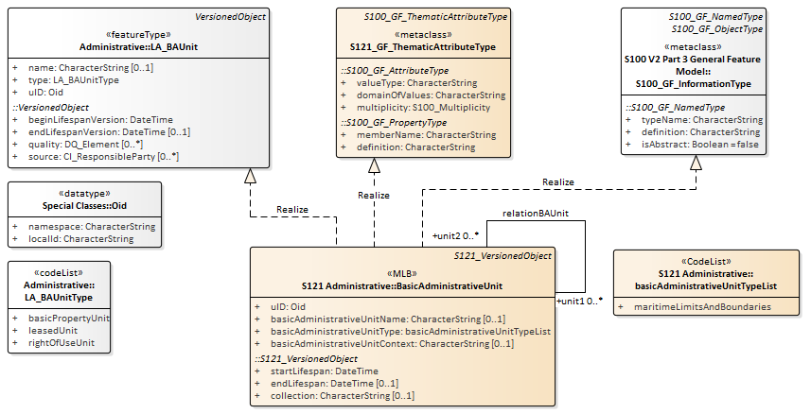

Figure 5 – S121 Basic Administrative Unit Inheritance

### Feature Unit

The Feature Unit is a realization of the class S121_FeatureType and as such the definition of the feature type can be included in the Feature Concept Dictionary. For example the feature type “Territorial Sea”, which would be used in a Maritime Limits and Boundaries Product Specification (S-121), would have a registered definition in the Feature Concept Dictionary. This feature type would also be able to take on the rights, responsibilities and restrictions and party administrative attributes through a relation to S121_BasicAdministrativeUnit.

The name of the feature is optionally defined in the attribute *name*. The *definition*, and *isAbstract* of the feature are recorded in the Feature Concept Dictionary so do not need to be included in attributes.

The attribute *fuID* is the feature unit identifier that is referenced by the other elements of the administrative attribute structure.

The attribute *name* provides a name of the feature unit. This may be the legal name by which a feature is known.

The attribute *label* provides an optional short textual identifier of the feature unit. This is often a code or similar identifier.

It is required to have either a name (*name*) or a label (*label*) on a feature unit. Since both the name and the label are recorded in the Feature Concept Dictionary for a Feature Type it is straightforward to convert from one type of identifier to the other. Some types of encodings, such as a human readable textual encoding would make use of the *name* since it is more readable than a *code*.

The attribute *legalStatusType* describes the type of the feature; e.g. Marine Limit and Boundary (MLB) or A76 from UNCLOS or other. This attribute takes on values from the class legalStatusTypeList.

The attribute *context* optionally describes the legal or administrative aspects of the feature object.

The attribute *releasabilityType* is optionally used to differentiate between "official", "development", "internal use", "in construction" or other status for particular features. This attribute takes on values from the class releasibilityTypeList.

Both the attributes *context* and *releasabilityType* support the ISO TC211 defined PT_Locale mechanism to allow for multilingual text.

The Feature Unit may be associated with one or more S121_SpatialAttributeTypes; that is, the geometry may be shared. This is the same shared geometry construct as established for all feature types defined using IHO S-100.

ISO 19152 allows spatial units to be organized into groups or layers. Since this capability of grouping already exists in S-100 it is not necessary to inherit a duplicate structure from ISO 19152.

Figure 6 shows the inheritance relationship for S121_FeatureUnit. Note that S121_FeatureUnit is also a versioned object.

There are two constraints on the relation from S121_FeatureUnit to S121_SpatialAttributeType. The multiplicity constraint states that only one Spatial AttributeType version may be associated with one FeatureUnit instance at one time. The type constraint states that all Spatial Attribute Types associated with a FeatureUnit shall be of the same geometric type Point, Curve or Surface. Versioning allows the Spatial Attribute instance to be changed, but not its type.

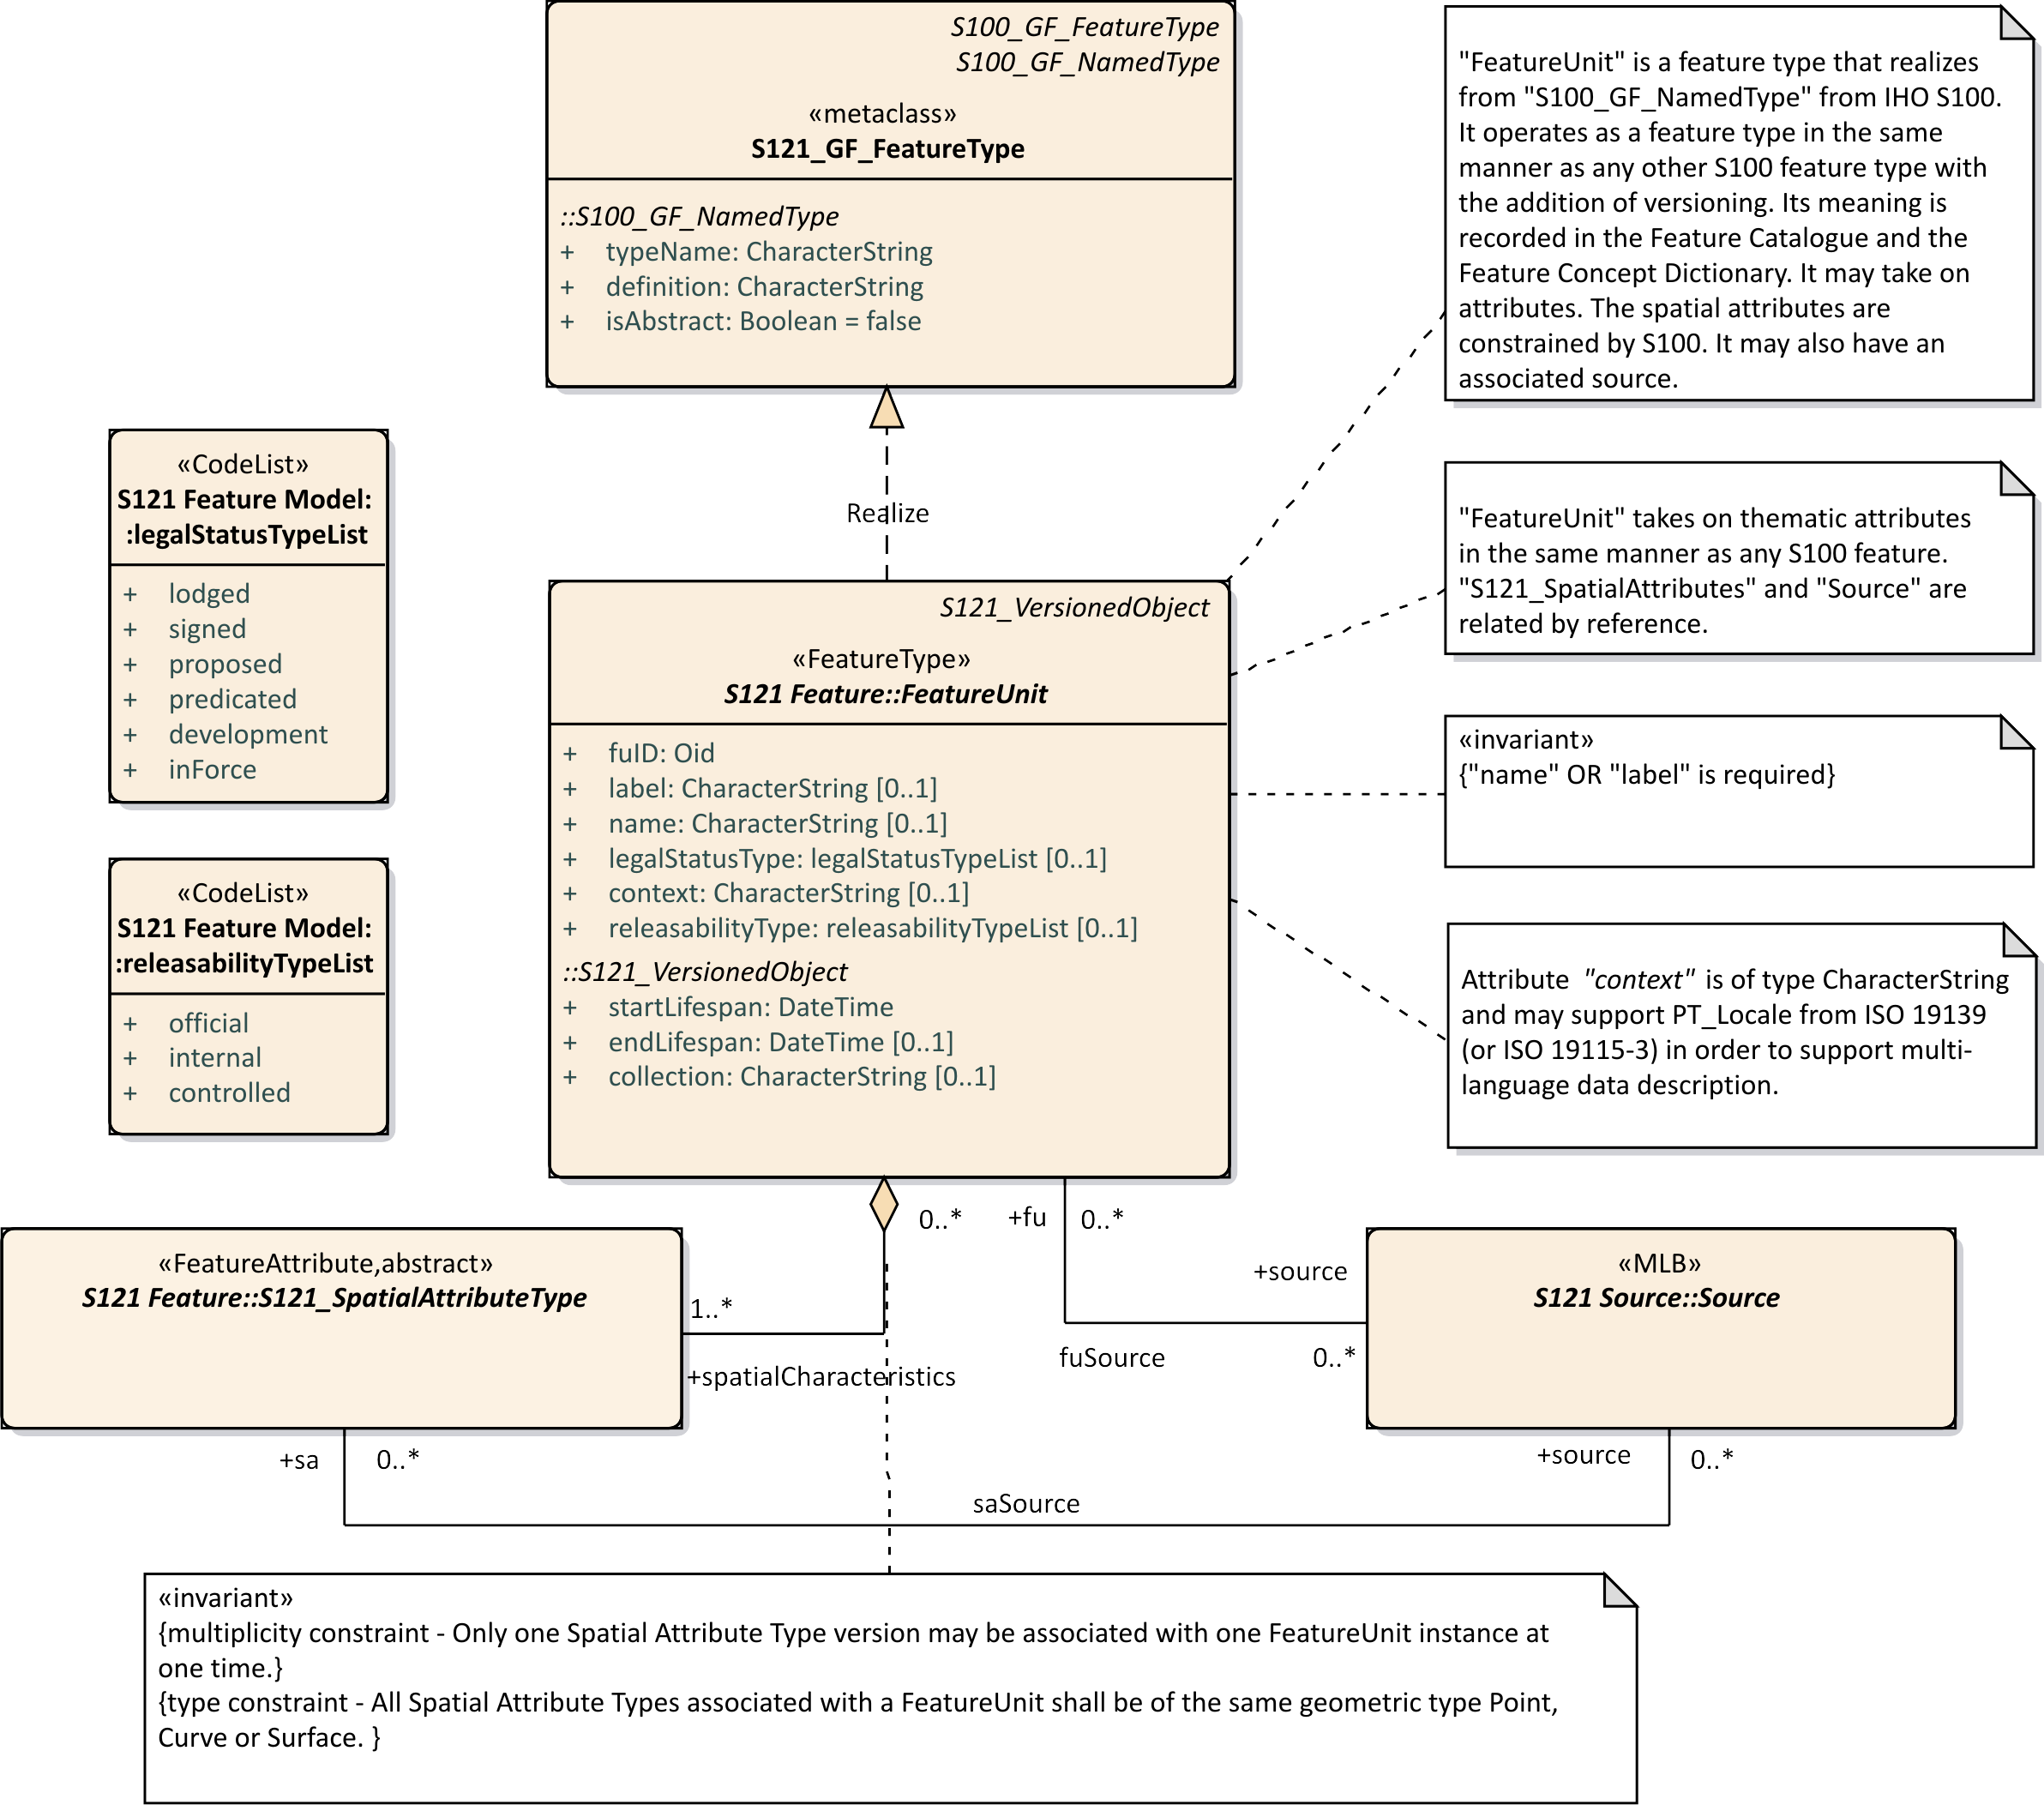

Figure 6 – S121 Feature Unit

### Spatial Attribute

The S121 SpatialAttributeType describes the spatial properties of an S121_FeatureUnit. It inherits from S121_GF_SpatialAttributeType and from the S-100 geometry model. This means that the geometry types inherited from S-100 apply. Only the geometry types GM_Point, GM_MultiPoint, GM_Curve, GM_Surface, CV_Coverage, GM_Curve (arcByCentrePoint and circleByCentrePoint) may be used. The S121 SpatialAttributeType derives from the S121_GF_SpatialAttributeType which is equivalent to the S100_GF_SpatialAttributeType. This maintains compatibility with other S-100 based products.

The ISO 19152 class LA_SpatialAttributeType makes use of the ISO spatial primitives GM_MuliCurve and GM_MultiSurface. IHO does not use the GM_Multi primitives except for GM_MultiPoint (for soundings). S-100 does support GM_Curve and GM_Surface, therefore the S121_SpatialAttributeType class supports these primitives. The composition is handled at the feature level through S121_FeatureUnit.

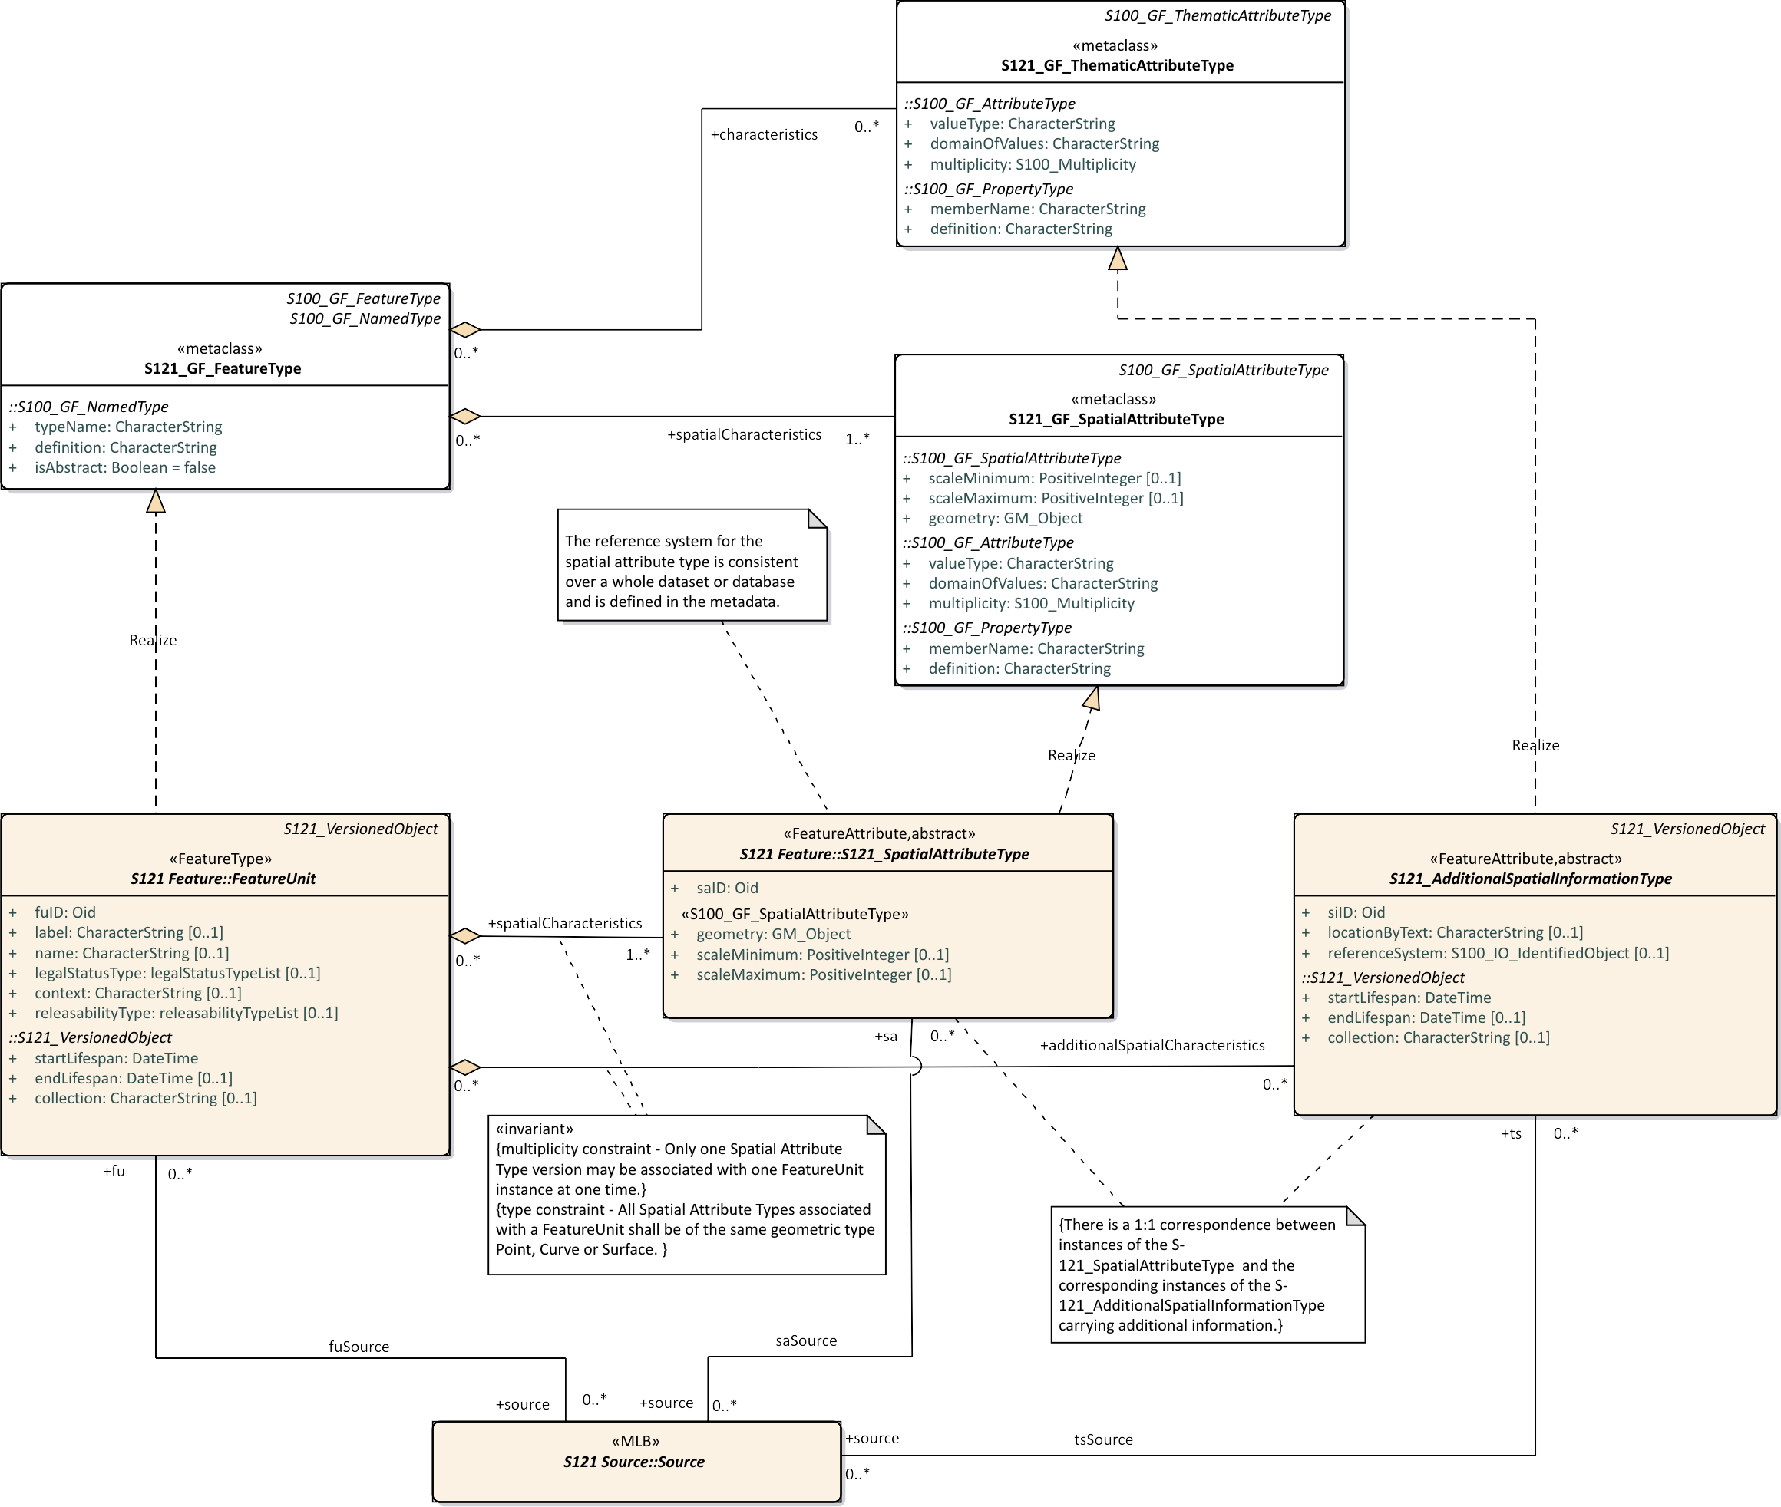

Figure 7 – S121 Spatial Attribute Type

Figure 7 shows the inheritance relationship for S121_spatialAttributeType. S121_spatialAttributeType implements the metaclass S121_GF_SpatialAttributeType through a Realize relation. That is the S121 SpatialAttributeType derives from the S121_GF_SpatialAttributeType which is equivalent to the S100_GF_SpatialAttributeType..

The attribute *saID* is the spatial attribute identifier that is referenced by the S121_FeatureUnit. In an implementation this may be the object identifier used in the implementation application schema.

Additional spatial attributes that do not participate in the geometry of the Geographic Information System (or GIS database or ECDIS) are defined as thematic attributes of a separate object. These attributes are inherited from ISO 19152. A separate class is defined called a “S121_AdditionalSpatialInformationType. This attribute class is versioned.

A constraint locks instances of the S121_AdditionalSpatialInformationType to the corresponding instances of the S121_SpatialAttributeType.

The attribute *siID* is the additional spatial attribute object identifier that is referenced by the FeatureUnit.

The attribute *locationByText* allows additional spatial information to be a textual description. This allows locations, limits, zones or spaces that are not fully described geometrically to be included.

The attribute *referenceSystem* allows a CoordinateReferencingSystem (CRS) to optionally be specified at the S121_spatialAttributeType level. In many other S-100 based products the CRS is only defined at the metadata level and applies for the whole data set; however, in S121 it is necessary to detail it right down to the specific instances of geometry since treaty points and lines may come from different sources such as different treaties that may use different CRS.

Figure 8 shows the S-100 classes used by the *referenceSystem* attribute.

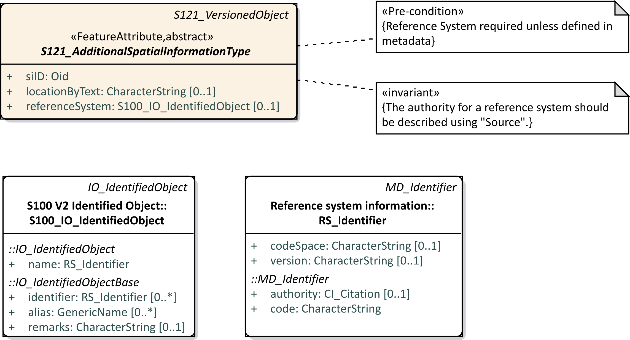

Figure 8 – S121 Reference System Attribute

Figure 9 shows an example of the use of the Multi-primitive GM_MultiSurface in a land cadaster environment. A farm land parcel object is crossed by a power line. In the land cadaster environment the farm would be one feature object that is defined by two surfaces using a GM_MultiSurface construct. In the marine environment there is a requirement from S-100 that each spatial primitive (except soundings) be a simple primitive. In this case one would generate two spatial attribute objects each with a single GM_Surface geometry. These two simple geometries would be combined into a complex with two parts. Both constructs are equivalent. In the marine environment the geometry is simpler whereas in the land cadaster environment the feature structure is simpler.

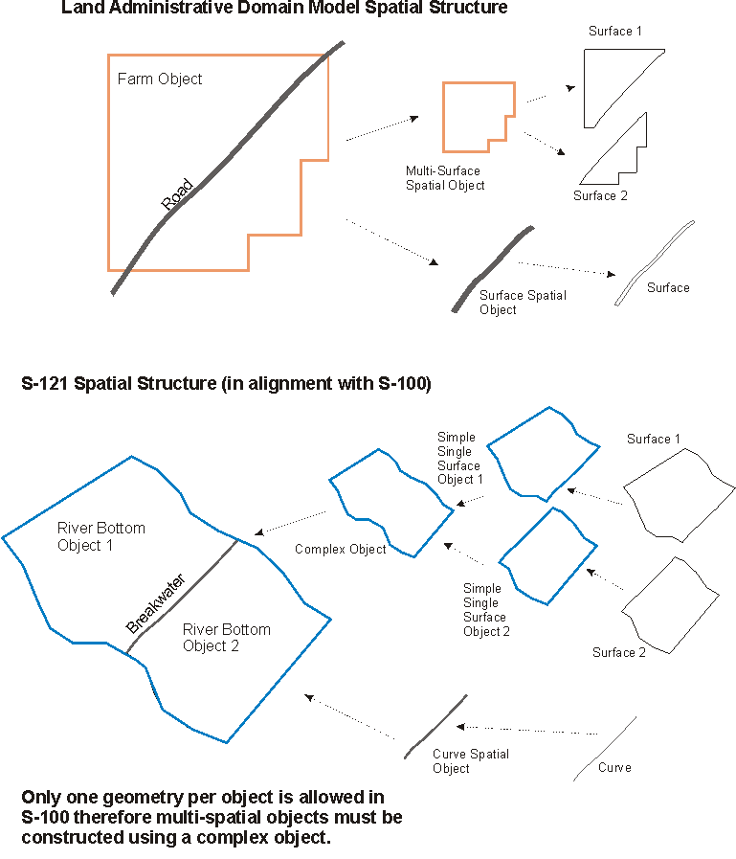

Figure 9 – Multi Element Spatial Structure

Since S-100 does not include any 3D spatial primitives. Support for space primitives must be constructed in the S-121 and in a Marine Cadaster. This is done by defining 3D objects as 2D objects with a height description. This can be done through attribution defining the vertical position and height of the object. The domains of rights for some of the UNCLOS**[4]** feature objects have different vertical extents.

Figure 10 shows spatial geometry at the feature type level. The four feature types Location, Limit, Zone and Space have different relations to the ISO 19152 spatial elements. They also carry different primitives. The ISO 19152 LADM has a very different structure for its spatial geometry designed to support land cadaster. ISO 19152 specifically states that it uses a survey approach. The spatial and feature elements are combined in single feature type objects. S-100 separates features types and spatial attribute types. Figure 10 shows the realization of attributes, some to S121_FeatureUnits and some to S121_spatialAttributeTypes.

An important attribute is *locationByText*. This allows a spatial attribute to be described textually instead of geometrically. This situation occurs within treaties or other MLB authoritative documents and must be represented. Sometimes it is because a Location, Limit, Zone or Space is not known or sometimes it is because of legal or political reasons where there is no agreement and the use of coordinates may be prejudicial. If spatial geometry and text are both provided then the geometry may be considered as an approximation and the text as descriptive.

*locationByText* is necessary because it is often the case in treaties, laws or other administrative documents where some information, usually the defining points, are provided geometrically and other information, such as the description of some limits and zones are only provided textually. For example a Territorial Sea may be described as an area bounded by a Territorial Sea Outer Limit and the coastline and baseline. The only geometry provided may be the baseline points and coastline geometry. The Territorial Sea Outer Limit object may have a *locationByText* description saying that it is 12 miles seaward according to a calculation. No actual geometry may be given. From this amount of information one cannot draw the Territorial Sea Outer Limit object, but it is the information in the treaty and must be represented in the standard.

Optional feature to feature relations are provided between the Location, Limit, Zone and Space objects to allow objects such as the Territorial Sea to be associated with their defining Limits and Location points. Where fully described geometric relationships between geometric spatial attributes are provided they take precedence over the feature to feature relations. Since administrative attributes such as Rights only apply to Zones and Spaces it is necessary to have a mechanism to relate a Zone or a Space to Limits and Location points at the feature level.

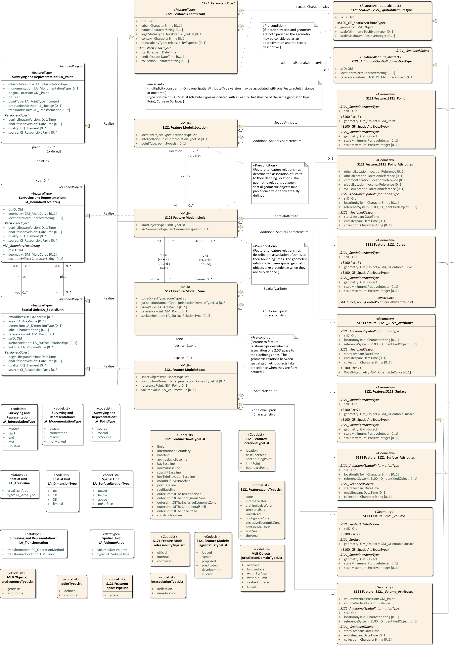

Figure 10 – Spatial Geometry

The Basic Administrative Unit (BasicAdministrativeUnit) relates to the S121_FeatureUnit to provide administrative attributes of Rights, Restrictions or Responsibilities. These are attributes by reference of the FeatureUnit through the S121_BasicAdministrativeUnit and S121_RightsRestrictionsResponsibility information objects. This is shown in Figure 11.

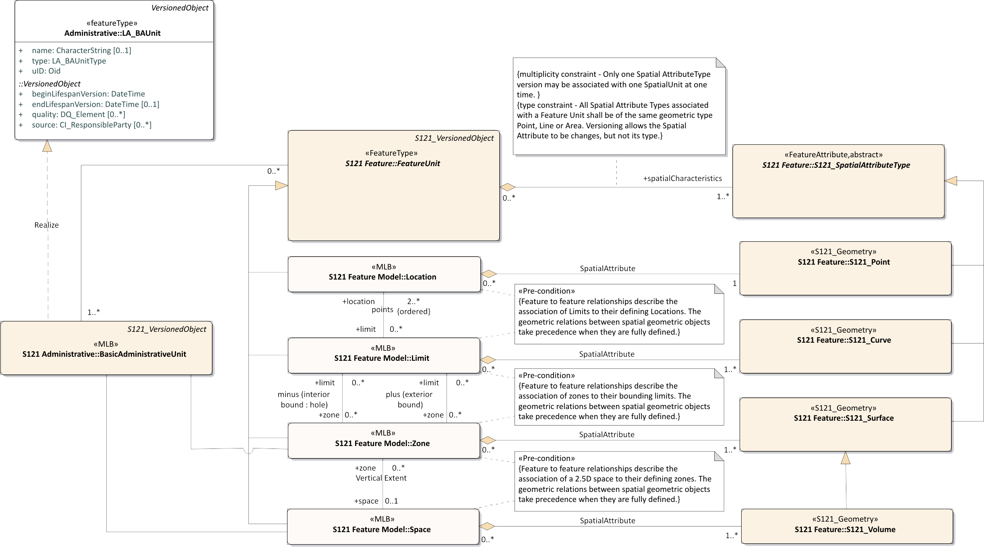

Figure 11 – Relation of Administrative Structure to Feature Unit

As illustrated in Figure 7 a source may optionally be defined for a feature and a spatial attribute. Source may also be defined for a Basic Administrative Unit, Rights, Restrictions and Responsibilities and Parties in the Administrative attribute structure. Figure 12 shows details of the S121_Source and its derivation from the ISO 19152 classes. There are two subtypes of source defined in ISO 19152. In S-121 these are combined into a single type with an attribute to distinguish their type. At least one of the three attributes adminSourceType, spatialSourceType, or sourceType is required. These code lists are Maritime Limits and Boundaries specific.

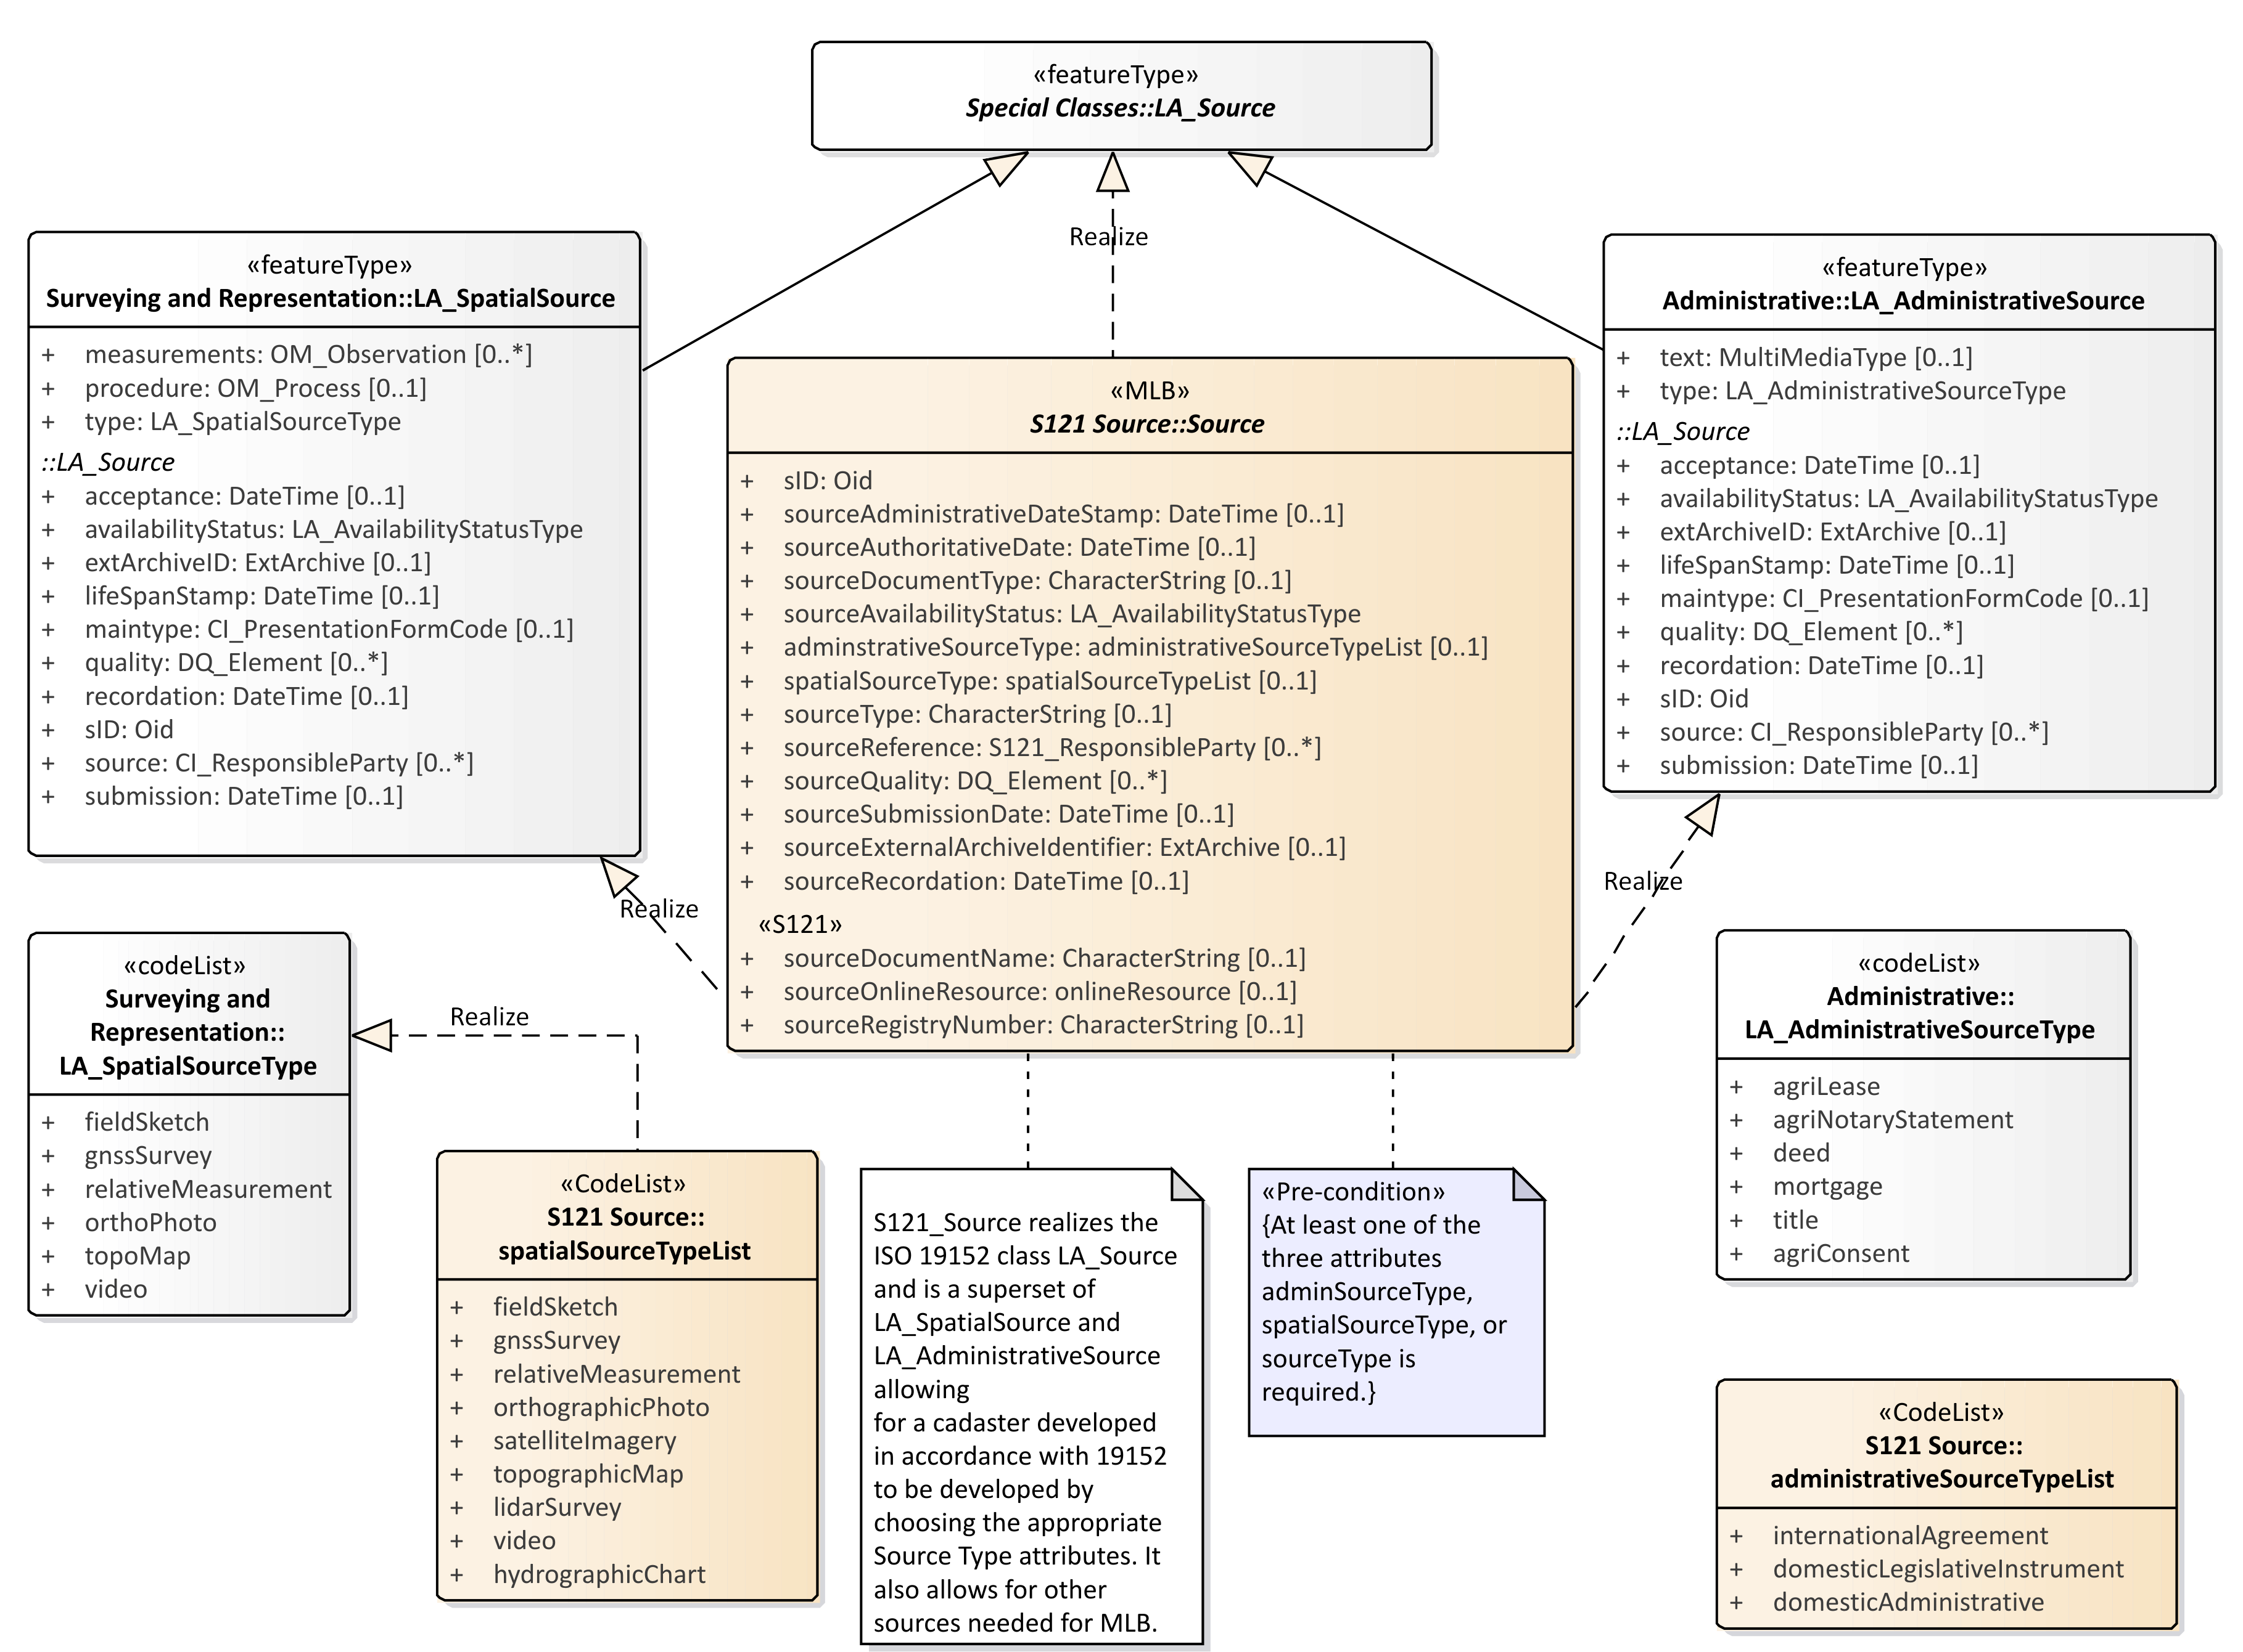

Figure 12 – Source

Figure 13 shows the S121_Source object with the associated code lists and associated support classes. A set of attributes, stereotyped S121, explicitly describe the information pertinent to source documents in a legal environment. These are:

* ***sourceDocumentName*** – Document name - for example the document (legislation, treaty, title) that defines the object;
* ***sourceOnlineResource*** – official URL (or equivalent online resource) where the document is distributed;
* ***sourceRegistryNumber*** – Unique official identifier of the record in a registry. For example, in states with registers of legislative instruments, versioning is controlled by the legislative registry ID;

The other S121_Source attributes are:

* ***sID*** – the identifier of the source;
* ***sourceAdministrativeDateStamp*** – the moment that the event represented by the instance of S121_Source is further processed;
* ***sourceAuthoritativeDate*** – the date of force of law of the source by an authority;
* ***sourceDocumentType*** – the type of document;
* ***sourceAvailabilityStatus*** – the status of document from the code list LA_AvailabilityStatusType;
* ***administrativeSourceType*** - descriptive documentation that supports, complement or describes the associated object;
* ***spatialSourceType*** - The type of spatial "Source" document;
* ***sourceType*** - The type of "Source" document Reference:
* ***sourceReference*** – reference to source through the class S121_ResponsibleParty;
* ***sourceQuality*** – Data Quality description through the metadata class DQ_Element;
* ***sourceSubmissionDate*** – The date of submission of the source by a party;
* ***sourceExternalArchiveIdentifier*** – The identifier of a source in an external registration;
* ***sourceRecordation*** - The date of registration (recordation) of the "Source" by registering authority.

The code lists and classes referenced are:

* **DateTime** – a data type for recording clock time;
* **LA_AvabilityStatusType** – a code list identifying the status of a source archive;
* **SpatialSourceTypeList** - Category of "spatialSourceType" (from ISO 19152:2012);
* **AdministrativeSourceTypeList** - Category of "administrativeSourceType" (from ISO 19152);
* **responsibleParty** - The responsible party of the "Source";
* **CI_RoleCode** - Responsible Party Role;
* **EX_Archive** – metadata about an external archive;
* **CI_PresentationFormCode** – a code list identifying the mode in which the source data is represented;
* **DQ_Element** – a metadata class describing data quality of the source data;
* **DQ_EvaluationMethodTypeCode** – a code list of the method used to evaluate data quality;
* **DQ_Result** – results of the data quality evaluation;
* **CI_RoleCode** – a code list of information about the function performed by the responsible party for the source data;
* **CI_OnlineFunctionCode** – a code list of the online function performed by an online resource as part of a contact for a responsible party for a source;

In addition the ISO metadata class CI_ResponsibleParty has been realized in S-121 to be ResponsibleParty. This includes the classes Contact, OnlineResource and Address that are realizations of the ISO classes CI_Contact, CI_Address and CI_OnlineResource. The attributes and inheritance of S121_Source are shown in Figure 13.

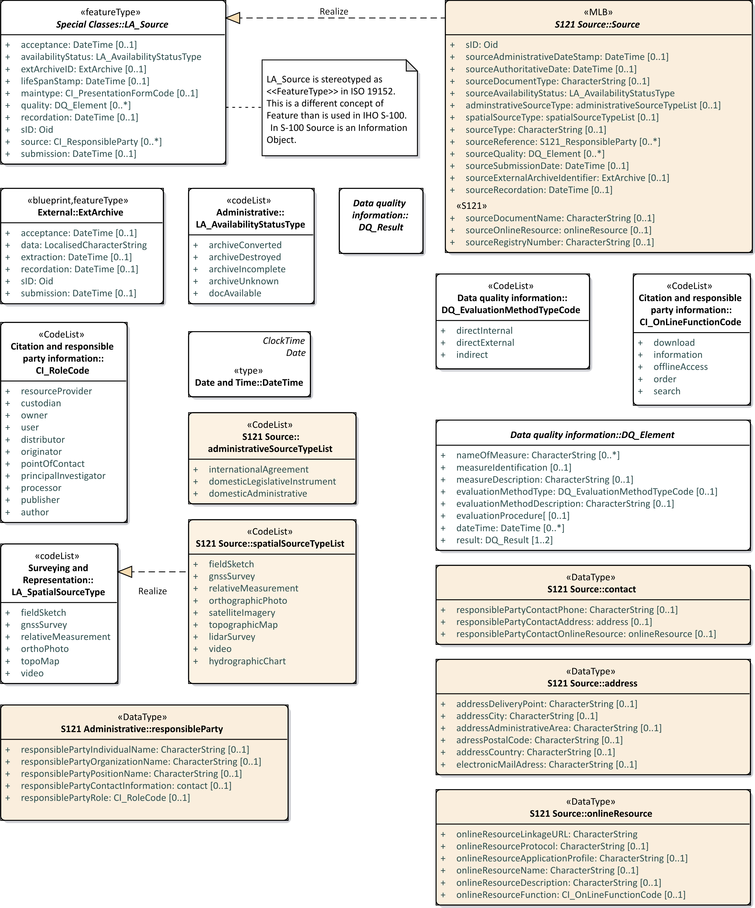

Figure 13 – S121_Source Attributes

### Party Unit Package

A party is “a person or organization that plays a role in rights[5]”. A Party is considered as an object. By treating parties (and rights, restrictions and responsibilities) as objects it means that they can be shared between features and also they can have attributes such as source and versioning applied to them. ISO 19152 has a Party model that allows for the establishment of groups as well as individual parties as individual objects. This is shown in Figure 14 which is based on the model in ISO 19152.

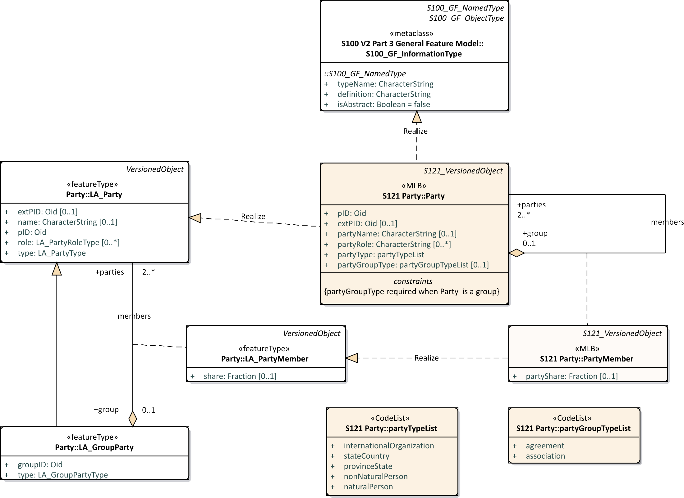

Figure 14 – S121 Party Package

ISO 19152 states that “The basic class [is] LA_Party (with party as an instance). LA_Party has a specialization: LA_GroupParty (with group party as an instance). Between LA_Party and LA_GroupParty there is an optional association class: LA_PartyMember (with party member as an instance). … A group party, being a specialization of party, is also a party.” This means that the aggregation relationship between S121_Party and S121_GroupParty in Figure 14 creates group parties with (registered) parties as constituents. An individual may be a member of a group, and a group as a whole can be treated as a party. "Every party, being a constituent of a group party, may then be registered as a party member of class LA_PartyMember[6]". This structure allows instances of individuals and groups to be uniquely identified. The S121_PartyMember class is effectively an optional attribute on the relationship of membership (members).

The relationship between Parties, Group Parties, Rights, Restrictions and Responsibilities and feature objects (S121_BasicAadministrativeUnit) is by reference through the Oid (Object ID). pID is the identifier of the party and optionally exPID is an identifier of the party in an external registration.

The attributes *partyType* and *groupPartyType* describe the Party and the Group Party.

The S121_Party is structured in an equivalent but simpler manner than ISO 19152.

### RRR Administrative Package

ISO 19152 defines an administrative package that associates parties with Basic Administrative Units. Most of this package also applies to S-121 (and also to Marine Cadaster).

An aggregate class LA_RRR is defined in ISO 19152 that has three specializations.

1. LA_Right, with rights as instances. Rights are primarily in the legal domain. A cadastre may define ownership rights. ISO 19152 provides code lists to support ownership within a national legal structure.

2. LA_Responsibility, with responsibilities as instances.

3. LA_Restriction, with restrictions as instances. Restrictions usually apply to objects independent of the rights; that is, the related party can change and the restriction remains.

Rights, responsibilities and restrictions appear as attributes for an S121_BasicAdministrativeUnit. These are subtypes of the collection class RightRestrictioinResponsibility. In the S121 model these classes are realizations of the ISO 19152 RRR classes.

In the ISO 19152 Land Administration Domain Model there are code lists which assign type to the rights, responsibilities and restrictions classes. These are land oriented types. For the marine environment these code lists have been replaced with code lists specialized to the marine environment. The code lists are: rightTypeList, restrictionTypeList, responsibilityTypeList.

Note: Code lists are used, rather than character strings in order to ensure consistency. This is a requirement from ISO 19152.

Also classes particularly aimed at Land Cadastre applications (such as mortgage) have not been expressed in the model. Since this is a realization, any of the ISO classes could be introduced into the S-121 (or Marine Cadaster) model if they are needed.

These objects are realizations of the S100_GF_InformationType. That is, they are object that may be referenced by other objects, but they do not carry spatial attributes. This is a preferable structure to introducing rights, responsibilities and restrictions as attributes of feature objects. Feature objects may point to the appropriate information objects using the Oid (Object ID) attribute. For example if a particular restriction applies to a fishing zone, then all features that invoke the restriction would point to the information object that establishes that restriction. If the restriction is changed it only needs to be changed once, not through the attributes in possibly hundreds of feature objects.

Figure 15 shows the S121 Administrative Rights, Responsibilities and Restrictions.

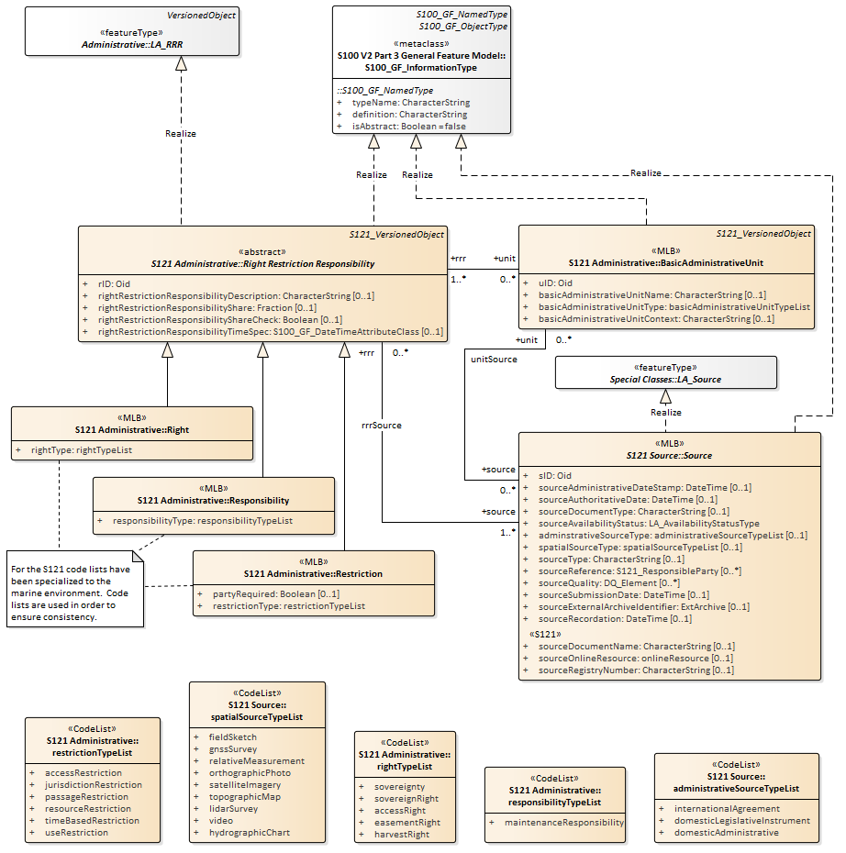

Figure 15 – S121 RRR Administrative Package

### RRR Structure

Figure 16 shows the combined structure of the attribute classes realized from the ISO 19152 LADM model. The Rights, Responsibilities and Restrictions provide guidance on how to define attributes that are included in the Feature Catalogue attributes. Each Right, Responsibility, and Restriction will be included in the Feature Catalogue as a separate simple or complex attribute.

The S121_Party is a non-spatial object which is an extension beyond S-100. The S121 Party classes are not features and do not need to be included in the Feature Catalogue. They are Information Objects. Individual parties are identified by the attribute values of the party classes.

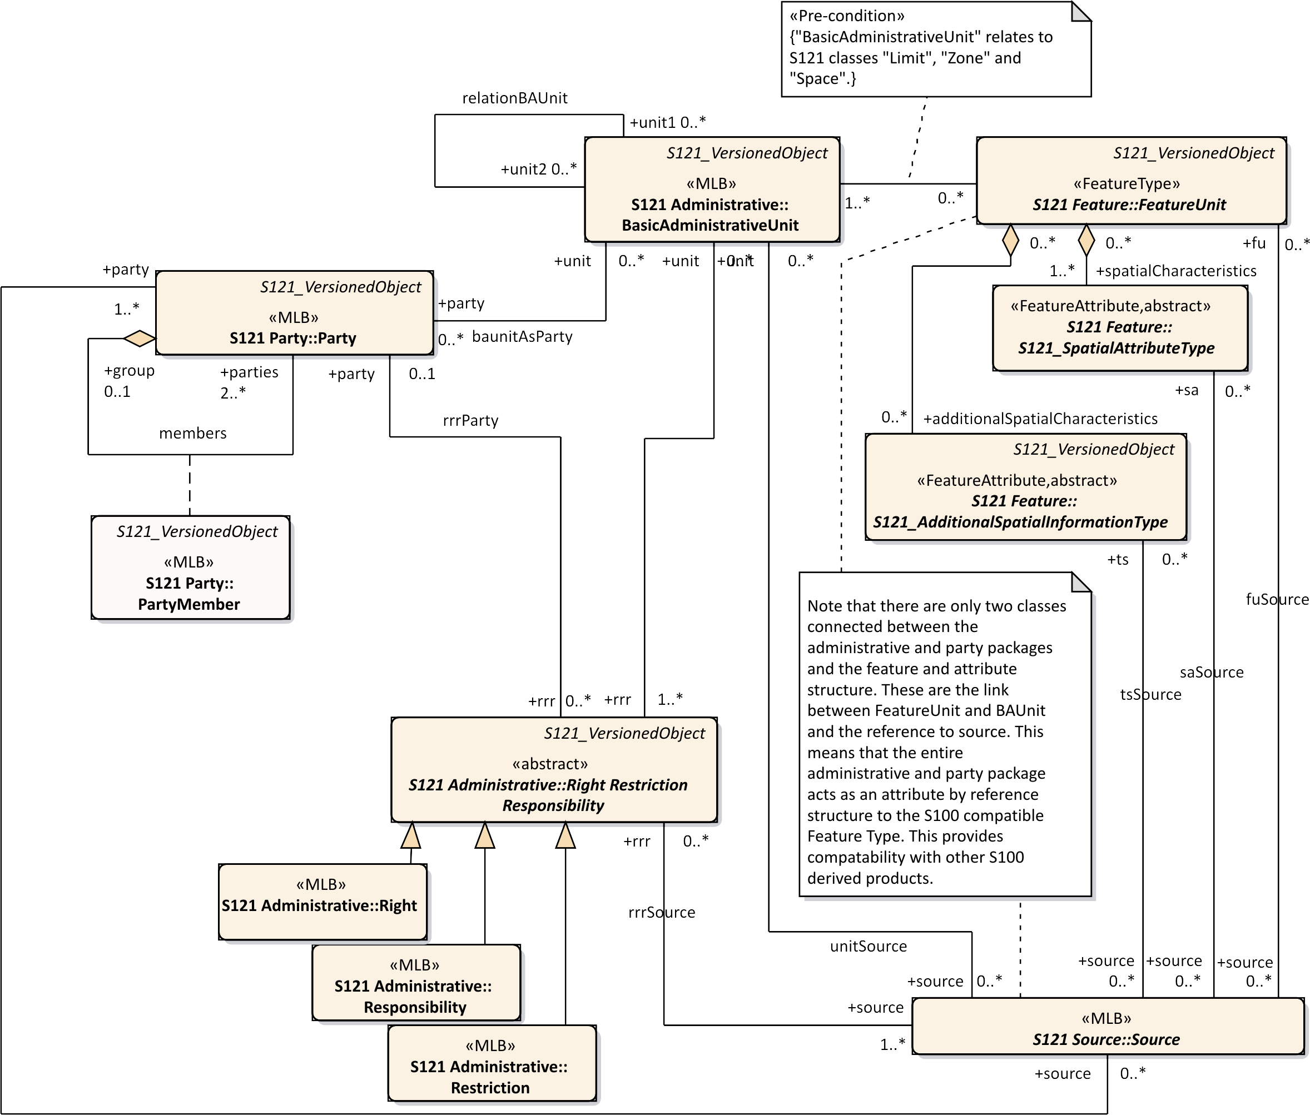

Figure 16 – S121 Party and RRR Structure

### Governance Object

Treaties and other descriptive legal documents normally contain a textual preamble that contains information specific to the legal status of the data, or exchange data set (such as a submission to DOALOS). This information requires another type of Information Object. This information object is called a governance object. This information is not metadata. It is part of the dataset containing specific legal text, but it may duplicate some metadata elements such as title. The governance data object may be versioned and can reference a source or sources.

All of the attributes of the governance object are optional except for the identifier attribute: *govID*. There may be zero or more (0..*) governance objects associated with a BasicAdministrativeUnit. When generating a data set from data held in the S-121 data model the governance objects associated with the Basic Administrative Units selected for output would be included with the output data.

There are several optional attributes that may be used to carry specific aspects of the textual preamble such as the title (governanceTitle), or the reference number (referenceNumber) of the data. The textual preamble would be carried as a character string in the governance description (governanceDescription) attribute.

The attributes are:

*govID* - Reference to information objects using the "Oid" (Object ID) attribute. The "Oid" comprises a unique character string and a namespace identifier which is also a unique character string. An example might be "Governance-1" where "Governance" is the namespace and "1" is the unique id within that namespace.

*referenceNumber* - The reference number of the legal reference.

*label* – A short textual identifier of the governance object.

*name* – The name of the governance object.

*governanceTitle* – The title of the legal reference.

*governanceDescription* – A character string containing the governance statement.

*releasibilityType* – Optionally used to differentiate between releasability status for particular features

*dateApproved* - The date at which the legal statement or document was approved by the appropriate governing body.

*dateConsidered* – The date at which the legal statement or document was considered by the appropriate governing body.

*dateIntroduced* - The date at which the legal statement or document was introduced.

Figure 17 shows the Governance Object structure.

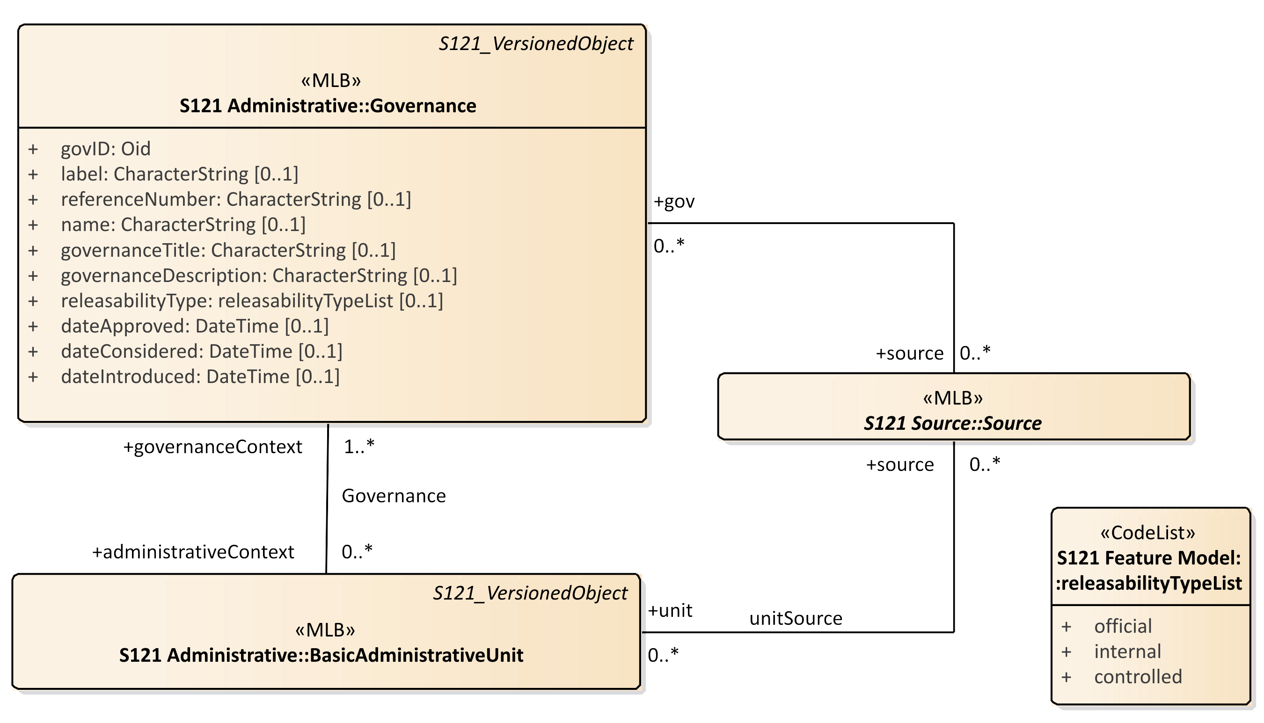

Figure 17 – Governance Object

### Versioned Object

The versioned object capability in ISO 19152 LADM allows objects to include a set of versioning attributes. These attributes consist of begin and end dates. This object has been realized from ISO. The optional quality and source attributes defined in ISO 19152 are not inherited.

The VersionedObject also contains the attribute *collection*. This attribute allows one to describe several different collections of data. For example the UN may hold data from Canada, France and other countries in the same database. There may be a unique numbering or naming system for feature and information object instances in Canada and another one in France, but there is no assurance that the two namespaces do not conflict. The *collection* attribute identifies which “collection” a data element is a member of. Effectively it ensures a unique namespace. This attribute is conditional. It is required in a database that contains information from different suppliers. The attribute is not required in a countries national database (if the country has a unique and unambiguous name or numbering system, and it is not required in an exchange data set because the metadata of the entire dataset uniquely identifies the dataset.

IHO S-100 allows for many feature types to be non-versioned. For example, features in an ENC would follow the S-101 Product Specification and would be non-versioned; however, whole ENC data product would be versioned. Versioned and non-versioned objects may be combined. A particular Product Specification would incorporate versioning by using the classes identified in Figure 18, which shows the S121 objects that inherit the versioning attributes.

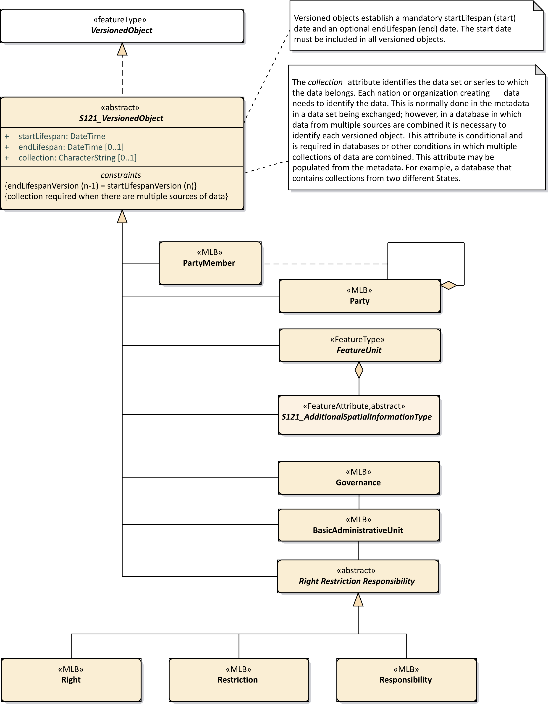

Figure 18 – Versioned Objects

# Using the S121 RRR Structure

ISO 19152 is a conceptual model standard. It provides elements that can be used in other standards such as the IHO S-100 standard series to structure data so that communities of interest can communicate using a shared vocabulary. ISO 19152 reflects the social relationship regarding rights, restrictions and responsibilities to a geographic area. This allows legal rights to be expressed.

The implementation of the S121 Party Unit Package and the S121 Administrative Package is done through the use of information objects. These information objects correspond to the classes in the S121 Party Unit Package and the S121 RRR Administrative Package. Each has an object identifier (Oid) so that it can be referenced. This means that, for example, an S121 Right Restriction or Responsibility versioned object can reference an S121_Party through a pointer implementing the *rrrParty* relationship. The other relationships between Party and Right Restriction Responsibility objects are implemented as pointers between information objects are *members* relating an S121_Party to an S121_GroupParty, *rrrSource* relating an S121_RRR information Object to an S121_AdministrativeSource information object and *conveyancerSource* relating an S121_Party information Object to an S121_AdministrativeSource information object.

These elements are implemented as information objects for two reasons. First of all, the fact that Rights, Responsibilities and Restrictions are information objects allows for the multiplicity available in the ISO 19152 conceptual model. A Feature Type, represented as an S121_FeatureUnit can reference any number of Rights, Responsibilities and Restrictions or Parties through the S121_BasicAdministrativeUnit. Also Rights, Responsibilities and Restrictions and Parties can be shared. The same right can apply to many objects. If a restriction changes, a new version of the S121_Restriction object can be generated and all of the objects that pointed to the old version of the restriction can be updated together.

Figure 19 presents a complete implementation model for the S121 structure. This is a simplification of the model shown in Figure 16 with relations navigable in one direction. This means that an implementation can use pointers in an exchange standard such as XML that allows repetition or simple single ended join tables in a database implementation. The direction of the pointers emanate from the Feature Type object ImplementationClass::S121_FeatureUnit to the feature spatial attributes and legal attribute structure. That is, the Feature Type object is the central object (as it is in S-100), and the legal administrative structure serves as an attribute structure. The administrative structure is more than a simple attribute but the reference is a simple reference that can be implemented in a simple attribute.

The object oriented structure of S-100 and the ISO 19152 standard allow for the integration of these two structures in a simple non-interfering manner. There are only logical connections between the Feature Type object (called S121_ FeatureUnit) and the S121 Administrative structure derived from ISO 19152. This means that the whole administrative structure acts as a separate entity referenced by the feature object carrying spatial and other feature thematic attributes.

The structure of the party group has been transformed in the implementation model. Since the GroupParty class inherited from ISO 19152 is a subtype of the Party class with an extra attribute, these two classes have been combined with the inclusion of a constraint that indicates that the additional attribute party group type (partyGroupType) is to only be used in a group party. The Party Member class then become a related object. This simplifies the implementation for those systems that cannot support a relationship class used for the purpose of carrying an association attribute.

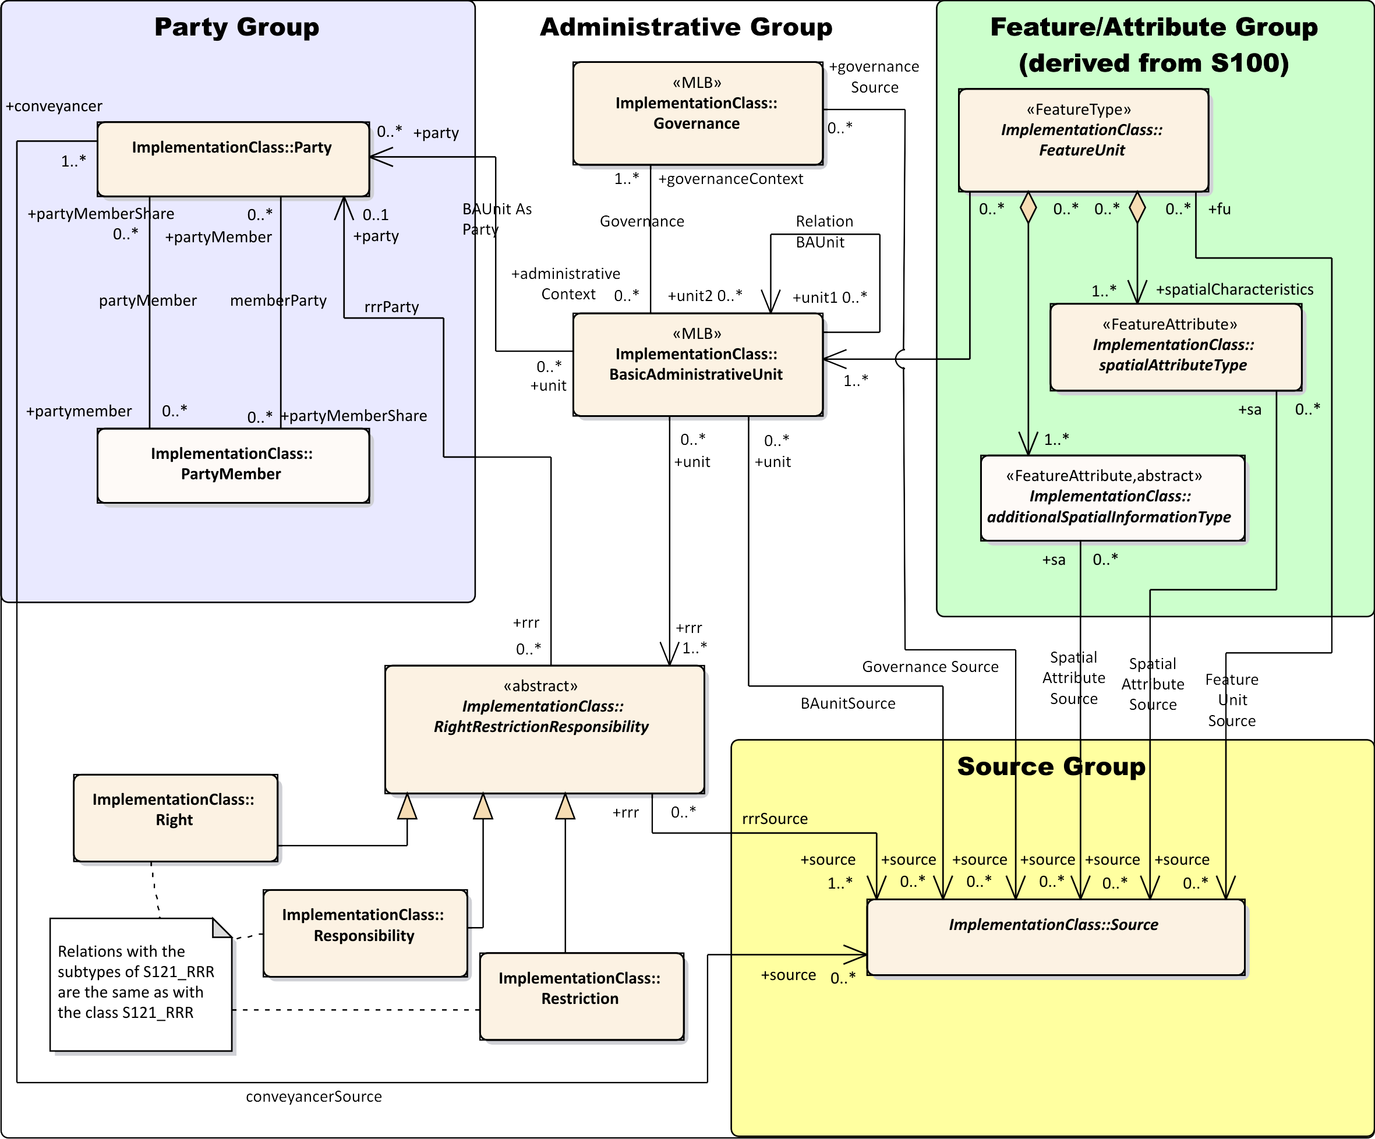

Figure 19 – S-121 Implementation Model

The implementation model shown in Figure 19 is simple. It contains only a small number of instantiable classes and all relations are navigable and unidirectional meaning that they can be represented as pointers (or single ended join tables in a database). There are four groups of classes, the Feature/Attribute Group (inherited from S-100), the Source Group, the Administrative Group and the Party Group.

**Feature/Attribute Group** - The class “ImplementationClass:: FeatureUnit” is a feature in the same way as any other feature in S-100, and it can take on both spatial attributes and other (non-legal) attributes in the same way as any S-100 feature. The class “ImplementationClass:: SspatialAttributeType” is the same as any spatial attribute in S-100.

**Source Group** - The classes “ImplementationClass:: Source is a simple information object that is only pointed to. These objects can be implemented as tables. The pointers are simple attributes in the classes that point to them. They take on attributes that describe source.

**Administrative Group –** The administrative group carry the legal attributes and the relations to parties. The class “ImplementationClass:: BasicAdministrativeUnit” is a table that is pointed to by the S-100 compatible Feature. That is, the pointer can be considered as a simple referenced attribute of the S-100 compatible feature object. This is the only link from the S-100 environment to the Legal Administrative environment (except for the simple attributes for version and source). The class “ImplementationClass:: BasicAdministrativeUnit” also points to the Right Restriction and Responsibility objects “ImplementationClass:: Right”, “ImplementationClass:: Responsibility” and “ImplementationClass:: Restriction”, “ImplementationClass:: Source”, and “ImplementationClass:: Party”. The pointer to “ImplementationClass:: Party” is there for completeness to match the ISO model, but is seldom needed.

The classes “ImplementationClass:: Right”, “ImplementationClass:: Responsibility” and “ImplementationClass:: Restriction” can also be implemented as simple tables with attributes. Each is the same and have two pointers, one to “ImplementationClass:: Source” and another to “ImplementationClass:: Party”.

**Party Group –** The class “ImplementationClass:: Party” is also a simple table with attributes. Its relation is a more complex structure because a party can be a group of individuals rather than just a single individual (or state). For example the signatories to a treaty could in some cases be a group. An optional attribute in the “ImplementationClass:: Party”, called “groupPartyType distinguishes whether the party is a single party or a group. The associated class “ImplementationClass:: PartyMember” provides the attribute “partyShare”. This is transformation of the model structure from the higher level model to make the implementation simpler on systems that do not support relationship classes for the purpose of carrying attributes.

Figure 20 illustrates a simple implementation that only uses Party and Right and Restriction (although Responsibility could be easily added). There is no relation established between the BasicAdministrativeUnit and Party. The abstract class is not shown, and the relations are direct between BasicAdministrativeUnit and Right and Restriction. This is common case.

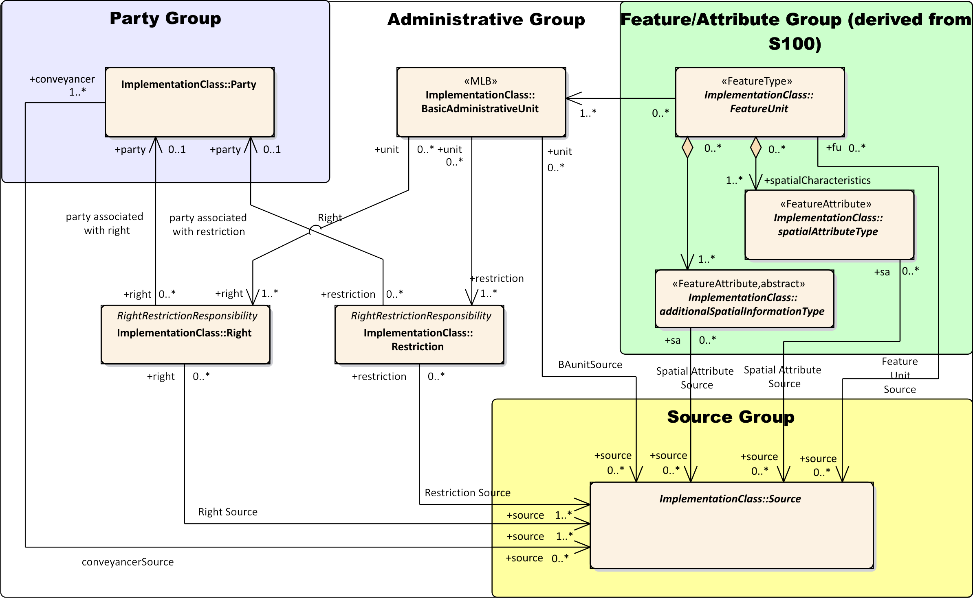

Figure 20 – Minimized S-121 Implementation Model

Page intentionally left blank

1. International Standard ISO 19152:2012 Geographic information -- Land Administration Domain Model (LADM), Clause 1 <https://www.iso.org/obp/ui/#iso:std:51206:en>
2. Electronic Chart Display Information System
3. A Web Feature Service is defined by OGC standard 09-025r1 and ISO standard 19142.
4. UNCLOS UN Convention on the Law Of the Sea
5. ISO 19152 LADM clause 4.1.13
6. ISO 19152 LADM clause 5.3